

Center Name: ACE-HCMC-2-FPT (VN 033)

Address: 590 Cach Mang Thang Tam street, district 3, Ho Chi Minh city, Viet Nam



**Web Based Claims Processing System**

**Development’s Guide**

**Faculty: Ngo Phuoc Nguyen**

**Batch No: F2-10-1203-T0**

**Group No: 02**

**Students:**

|  |  |  |
| --- | --- | --- |
| **No** | **Full Name** | **Roll No** |
| **1** | **Dang Tran Ngoc Phuong** | **Student625410** |
| 2 | Tran Ngoc Minh Khai | Student638864 |
| 3 | Tran Minh Duc | Student636621 |
| 4 | Tran Dung Tri | Student682906 |

**Table of contents**

Contents

REVIEW 1 2

1. Introduction 5

2. Existing Scenario 5

3. Customer Requirement Specification 5

4. Functional Requirement Specification 5

5. System Requirements 9

6. Development Software 10

7. Technology 10

Task sheet review 1 11

REVIEW 2 12

1. Use Case and Sequence Diagram 13

1.1. Guest 13

1.1.1. Register as New Account (Only Employee) 13

1.1.2. Contact the company 15

1.2. Employee 16

1.2.1. Login 17

1.2.2. Log out 18

1.2.3. Retrieve Password 19

1.2.4. Edit Profile 21

1.2.5. Create Claim 23

1.2.6. View Claim 24

1.3. Administrators 25

1.3.1. Login 26

1.3.2. Logout 27

1.3.3. Retrieve Password 28

1.3.4. Manage Account 29

1.3.5. Manage News 35

1.3.6. Manage Contact 42

1.3.7. Manage Claim 47

1.3.8. Manage Employee 54

1.3.9. Manage Insurance Product 61

2. Entity Relationship Diagram (ERD) 69

2.1. Conceptual 69

2.2. Logical 69

2.3. Tables 70

2.3.1. Admin 70

2.3.2. Employee 70

2.3.3. BankInfo 71

2.3.4. Account 72

2.3.5. Insurance 73

2.3.6. InsuranceType 74

2.3.7. Claim 75

2.3.8. FAQ 76

2.3.9. News 77

2.3.10. Contact 78

REVIEW 3 79

1. Database Relationship Diagram 80

2. Table Definition 81

*2.1.* *Admin* 81

*2.2.* *Employee* 81

*2.3.* *Account* 81

*2.4.* *Claim* 82

*2.5.* *InsuranceType* 83

*2.6.* *Insurance* 83

*2.7.* *BankInfo* 83

*2.8.* *Contact* 84

*2.9.* *News* 84

*2.10.* *FAQ* 85

REVIEW 1

# Introduction

P2P is a company which is having employee strength of at least 1500. All the employees are provided medical reimbursement facility which means that the expenditure incurred by the employee for treatment is reimbursed by the company.

Currently, the reimbursement is done by the hard-copy and sent to the Claims Processing Department (CPD) by messenger for processing. However, since this process has some problems and the number of employees is increasing, management is looking at ways of reducing the mistakes and workload for CPD.

# Existing Scenario

For reimbursement, the employee needs to fill in a form detailing the treatment undertaken which includes the name & cost of medicines, laboratory tests, surgery. The form is duly signed by the employee and it will be sent to the concerned CPD by messenger for processing. CPD will process it and the order regarding the reimbursement is sent to the Cash counter (CC) where the employee can come and receive the reimbursement amount.

Some of the problems associated with the above mentioned process are listed below:

* The form may miss during transit.
* The form is prone to weariness due to which the company may not be able to read data in it after some years.
* The employees who claimed for medical reimbursement need to visit the CC from time to time enquiring about the status of their application. This results in enormous wastage of time of the employee.

# Customer Requirement Specification

To overcome these problems, it is proposed to develop software titled Web Based Claims Processing System (WCPS) which is web based so that:

The employee can:

* Login into her/his account
* Fill and submit the form online to CPD through Internet
* Check the claim status and view the previous records of the claims

At CPD, the form needs to be checked automatically by a program which will compute the amount that needs to be reimbursed to the employee for the treatment undertaken. Any excess amount claimed by the employee is ignored by the software. Then, CPD can see and confirm the status for all the submitted claims. If any claim is approved, the amount computed will be routed to the e-mail account of the employee as well as to the Bank which holds the accounts of all the employees of the company. The bank will credit the amount to the account of the employee based on the mail.

# Functional Requirement Specification

* **EMPLOYEE**
  + **Employee can register an account online**

As an employee, she/he is given an account code so that she/he can register new account to make a claim online. It is done by filling the following information:

|  |  |
| --- | --- |
| **Information** | **Requirements** |
| Username | Unique |
| Password | New password is not same as previous |
| EmployeeID |  |
| AccountCode |  |
| Address |  |
| Email | Unique |
| PhoneNumber | Unique |
| BankName |  |
| BankAccount | Unique |

After registering successfully, new account is saved into database and it is ready for the employee to use.

* + **Login**

After successful registration, employee can login to her/his account by filling the username and password

|  |  |
| --- | --- |
| **Information** | **Requirements** |
| Username | Unique |
| Password |  |

* + **Logout**

After login, employee can logout her/his account if no need to do anything else.

* + **“Forget username or password”**

In case the employee forgets username or password, she/he can click on “Forget username or password” hyperlink in Login page to redirect to “Forget username or password” page, then input the following information:

|  |  |
| --- | --- |
| **Information** | **Requirements** |
| EmployeeID | Unique |
| AccountCode | Unique |

If the inputted EmployeeID and AccountCode are correct, an email is automatically sent to employee’s email to provide again her/his username and password.

* + **Update profile**

After login, the employee can update her/his profile (employee cannot change username, EmployeeID and AccountCode):

|  |  |
| --- | --- |
| **Information** | **Requirements** |
| Password | New password is not same as previous |
| Address |  |
| Email | Unique |
| PhoneNumber | Unique |
| BankName |  |
| BankAccount | Unique |

* + **Create new claim**

After login, the employee can create new claim for reimbursement by filling the information below:

|  |  |
| --- | --- |
| **Information** | **Requirements** |
| ClaimTitle |  |
| ProductID | Viewed in dropdown list |
| TotalAmount |  |
| ReimbursedAmount | Float (is automatically calculated) |
| Attachment | Attach only one file |
| Status | Approved/Processed/Cancelled |

When the ClaimType and TotalAmount are inputted, the ReimbursedAmount is automatically calculated and shown in this page

* + **View/search all claim status**

The employee can also search all the claim status by Date or Amount or Status:

|  |  |
| --- | --- |
| **Information** | **Requirements** |
| FromDate |  |
| ToDate | Later than FromDate |
| FromAmount |  |
| ToAmount | Greater than FromAmount |
| Status | Approved/Processed/Cancelled |

Or the employee can click on “View All” to see all the claim status.

* **ADMINISTRATOR**
  + **Login page for administrator**

The user can login as administrator by filling the username and password:

|  |  |
| --- | --- |
| **Information** | **Requirements** |
| Username | Unique |
| Password |  |

* + **Logout**

After login, admin can logout her/his account if no need to do anything else.

* + **“Forget username or password”**

In case the administrator forgets username or password, she/he can click on “Forget username or password” hyperlink in Login page for administrator to redirect to “Forget username or password” page, then fill the following information:

|  |  |
| --- | --- |
| **Information** | **Requirements** |
| EmployeeID | Unique |
| AccountCode | Unique |

If the inputted EmployeeID and AccountCode are correct, an email is automatically sent to administrator’s email to provide again her/his username and password.

* + **Manage employees (view/insert/update/delete/search/restore)**

Admin can view/insert/update the employee profile by filling/modifying following information:

|  |  |
| --- | --- |
| **Information** | **Requirements** |
| EmployeeID | Unique |
| EmployeeName |  |
| AccountCode | Unique: employee uses to register online |
| EmployeeTitle |  |
| Address |  |
| Email | Unique |
| PhoneNumber | Unique |
| BankName |  |
| BankAccount | Unique |
| isActive |  |

Besides, admin can search or delete one employee by employeeID or employeeName

* + **Manage accounts (view/insert/update/delete/search/restore)**

Admin can insert/update an account by filling the following information:

|  |  |
| --- | --- |
| **Information** | **Requirements** |
| Username | Unique |
| Password | New password is not same as previous |
| EmployeeID | Viewed in dropdown list |
| AccountCode |  |
| Address |  |
| Email | Unique |
| PhoneNumber | Unique |
| BankName |  |
| BankAccount | Unique |
| isActive |  |

Besides, admin can view all the accounts and search or delete one account by Username or EmployeeID.

* + **View/search/delete/restore claims and update claim status**

Admin can view all the claims and search/delete claims by filling the following information:

|  |  |
| --- | --- |
| **Information** | **Requirements** |
| ClaimID |  |
| ProductID | Viewed in dropdown list |
| FromAmount |  |
| ToAmount |  |
| Status | Approved/Processed/Cancelled |
| EmployeeID | Unique |
| ClaimDate |  |
| isActive |  |

Moreover, admin can update the claim status. As soon as the status is set “Approved”, two emails will be sent to the employee and bank to proceed the payment.

* + **Manage insurance products (view/insert/update/delete/search/restore)**

Admin can insert/update the insurance products by filling the following information:

|  |  |
| --- | --- |
| **Information** | **Requirements** |
| ProductID | Unique |
| ProductName | Unique |
| maxAmount |  |
| DateCreated |  |
| Description |  |
| isActive |  |

Besides, admin can view all the insurance products and search or delete by ProductID, ProductName or maxAmount, DateCreated.

* + **Manage company news (view/insert/update/delete/search/restore)**

Admin can insert/update the company news by filling the following information:

|  |  |
| --- | --- |
| **Information** | **Requirements** |
| NewsID | Unique |
| NewsTitle | Unique |
| Content |  |
| DateCreated |  |
| isActive |  |

Besides, admin can view all the news and search or delete by NewsID, NewsTitle or DateCreated.

* + **Manage contacts (view/search/delete/restore)**

Admin can view all the feedbacks and search/delete feedbacks by filling the following information:

|  |  |
| --- | --- |
| **Information** | **Requirements** |
| FeedbackID | Unique |
| FeedbackTitle |  |
| FeedbackContent |  |
| SenderEmail |  |
| DateSent |  |
| isActive |  |

* **GUEST**
  + **View news and insurance products**

As a guest, she/he can access the website to see all the company information, news and insurance products, which are updated by admin.

* + **Contact company**

Guest can also create new feedback and send it from the website by filling the following information:

|  |  |
| --- | --- |
| **Information** | **Requirements** |
| ContactTitle |  |
| SenderEmail |  |
| Content |  |



# System Requirements

5. 1. ***Hardware***
      1. **Web Server**

|  |  |
| --- | --- |
| Processor | Pentium IV or higher. |
| Memory | 512MB RAM or greater. |
| Modem/ADSL | Connecting to internet 24/24 |

* + 1. **Client**

|  |  |
| --- | --- |
| Processor | Pentium IV or higher. |
| Memory | 512MB RAM or greater. |
| Monitor | Super VGA (800x600) or higher resolution with 256 colors. |
| Pointing Device | Microsoft Mouse, Microsoft IntelliMouse®, or compatible pointing device. |
| Modem/ADSL | Connecting to internet |

* 1. ***Software***
     1. **Web Server**

|  |  |
| --- | --- |
| Operation System | Windows 2003 |
| Browser | Internet Explorer 7.0 or higher. |
| Database | Microsoft SQL Server 2008 |
| Software | Java SDK 1.7 |
|  | GlassFish 4.0 |
|  | PrimeFaces 3.5 |

* + 1. **Client**

|  |  |
| --- | --- |
| Operation System | Windows 7 or later. |
| Browser | Internet Explorer 7.0 or higher. |

# Development Software

* Microsoft Windows 7
* NetBeans 7.3.1
* Java SDK 1.7
* GlassFish 4.0
* Microsoft SQL Server 2008
* Internet Explorer 8.0
* TortoiseSVN 1.7

# Technology

* J2EE
* Java Web Service
* JSP, Servlet
* HTML
* EJB
* Jquery

# Task sheet review 1

|  |  |  |  |  |  |
| --- | --- | --- | --- | --- | --- |
| Project Ref. No: 01 | Project Title:  Web Based Claims Processing System | Date of Preparation of Activity Plan | | | |
| No. | Task | Actual Start Date | Actual Days | Team Member Names | Status |
| 01 | Introduction | Sep 25, 2013 | 2 | All Members | Completed |
| 02 | Existing scenario | All Members | Completed |
| 03 | Customer Requirement Specification | All Members | Completed |
| 04 | Function Requirement Specification | All Members | Completed |
| 05 | System requirements | All Members | Completed |
| 06 | Task sheet | All Members | Completed |

|  |  |  |
| --- | --- | --- |
|  | **Prepared by (Student)** | **Approved by (Faculty)** |
| **Signature** | **All members** | **Ngo Phuoc Nguyen** |
| **Date** |  |  |

REVIEW 2

# 

# 

# Use Case and Sequence Diagram

## Guest

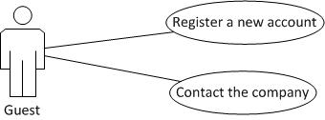

### Register as New Account (Only Employee)

|  |  |  |
| --- | --- | --- |
| **Author** | Tran Ngoc Minh Khai | |
| **Use Case Name** | Register a New Account | |
| **Actors** | Guest | |
| **Description** | Guest (employee) wants to register with the website to have a new account | |
| **Requirements** | Employee provides Employee’s information | |
| **Pre-conditions** |  | |
| **Post-conditions** | Success: Employee creates a new account in this website  Fail: Refill information | |
| **Basic flow** | Actor Actions:  1. Actor clicks ‘Register’ link in Home page.  4. Actor inputs register’s information and click ‘Register’ Button. [Alternative 1] | System Responses:  2. System redirects to Registration page.  3. System redirects to Register page and displays Registration form with the following control :  - ‘UserName’ text field  - ‘Password’ text field  - ‘Confirm Password’ text field  - ‘EmployeeID’ text field  -‘Name’ text field  - ‘Birthday’ datebox  - ‘Gender’ checkbox group  - ‘Address’ text field  - ‘Phone’ text field  - ‘Email’ text field  -‘AccountCode’ text field  -‘BankName’ text field  -‘BankAccount’ text field  - ‘Captcha’ textbox  - ‘Refresh image’ button  - ‘Register’ button  - ‘Back to Home’ button  5. System checks the information  [Exception 1]  6. System inserts the account into database, show message: ‘Your account has been created!’ and then redirects to Login page. |
| **Alternative flow** | Actor Actions:  [Alternative 1]  1. Actor click ‘Back to Home’ button. | System Responses:  2. System returns to Home page. |
| **Exception** | Actor Actions:  [Exception 1]  1. Actor lefts ‘UserName’ text field blank.  2. UserName has already exists.  3. Actor lefts ‘Password’ text field blank.  4. Actor lefts ‘Confirm Password’ text field blank.  5. Password and confirm password don’t match.  6. Actor lefts ‘AccountCode’ text field blank.  7. Actor lefts ‘Birthday’ datebox blank.  8. Input age to ‘Birthday’ datebox less than 16.  9. Actor lefts ‘Address’ text field blank.  10. Actor lefts ‘Phone’ text field blank.  11.Input phone not in numeric or phone length not in range 8 – 14 character.  12. Actor lefts ‘Email’ text field blank or input an invalid email address.  13.Actor lefts ‘BankName’ text field blank.  14. Actor lefts ‘BankAccount’ text field blank.  15. Actor lefts ‘EmployeeID’ text field blank  16. Actor lefts ‘Name’ text field blank  17. Actor left ‘Captcha’ text field blank or input an unmatch value. | System Responses:  System displays message to Actor :  - ‘UserName cannot be blank’.  - ‘This Username has already exist!’.  - ‘Password cannot be blank’’.  - ‘Confirm Password can’t be blank’.  - ‘Confirm password not match password.’  - ‘AccountCode cannot be blank’.  - ‘Birthday is invalid’.  - ‘Age must over 17’.  - ‘Address cannot be blank’.  - ‘Phone is invalid’.  - ‘The phone number should be numeric only and must be between 8 and 14 digits’.  - ‘Email is invalid’.  - ‘BankName cannot be blank’.  -‘BankAccount cannot be blank’  -‘EmployeeID cannot be blank’  -‘Name cannot be blank’  - ‘Not match the image’. |

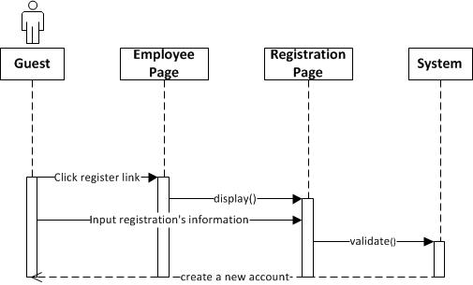

### Contact the company

|  |  |  |
| --- | --- | --- |
| **Author** | Tran Ngoc Minh Khai | |
| **Use Case Name** | Contact the company | |
| **Actors** | Guest | |
| **Description** | Guest wants to contact the company | |
| **Requirements** | Guest provides information to contact | |
| **Pre-conditions** |  | |
| **Post-conditions** | Success: Guest send an email to the company with the contact’s information  Fail: Refill information. | |
| **Basic flow** | Actor Actions:  1. Actor clicks ‘Contact’ button in Home page menu bar  3. Actor inputs Contact’s information and click ‘Submit’ button. [Alternative 1] | System Responses:  2. System redirects to Contact page and displays Contact form with the following control :  - ‘Name’ text field  - ‘Address’ text field  - ‘Phone’ text field  - ‘Email’ text field  - ‘Subject’ text field  - ‘Content’ text field  - ‘Submit’ button  - ‘Cancel’ button  4. System checks the information.  [Exception 1]  5. System add contact to the database andshow success message |
| **Alternative flow** | Actor Actions:  [Alternative 1]  1. Actor click ‘Cancel’ button. | System Responses:  2. System returns Home page. |
| **Exception** | Actor Actions:  [Exception 1]  1. Actor lefts ‘Content’ textfield blank.  2. Actor lefts ‘Email’ text field blank or input an invalid email address. | System Responses:  System displays message to Actor :  - ‘Content cannot be blank’.  - ‘Email is invalid’. |

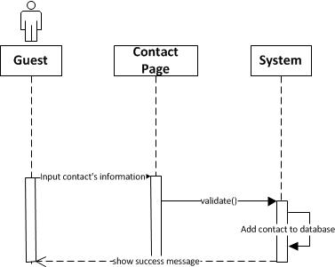

## Employee

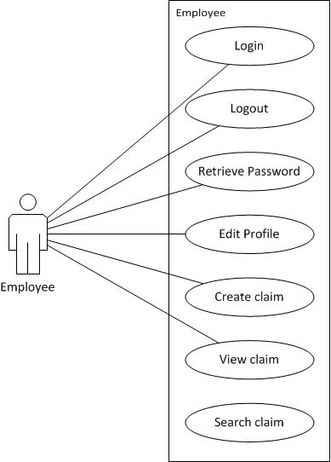

### Login

|  |  |  |
| --- | --- | --- |
| **Author** | Tran Ngoc Minh Khai | |
| **Use Case Name** | Login | |
| **Actors** | Employee | |
| **Description** | Employee wants to login to website as a Employee account. | |
| **Requirements** | Actor provides username and password | |
| **Pre-conditions** |  | |
| **Post-conditions** | Success: User logged in to website.  Fail: Refill information | |
| **Basic flow** | Actor Actions:  1. Actor go to Home page and click ‘Login’ link.  3. Actor inputs UserName and Password, then click the Login button. | System Responses:  2. System redirects to Home page and displays Login form on the left with the following control:  - ‘UserName’ text field  - ‘Password’ text field  - ‘Login’ button  4. System checks the information  [Exception 1]  5. System redirects to Actor’s Home page. |
| **Alternative flow** | Actor Actions:  [Alternative 1]  1. Actor click ‘OK’ button, inputs UserName and Password, then click the Login button.  [Alternative 2]  4. Actor click ‘Back to Home’ button. | System Responses:  2. System checks the information  [Exception 1]  3. System redirects to Actor’s Home page.  5. System returns to Home page. |
| **Exception** | Actor Actions:  [Exception 1]  1. Actor input invalid username and password. | System Responses:  - System redirect to Login page with the following controls:  - ‘UserName’ text field  - ‘Password’ text field  - ‘Login’ button.  - ‘Back to Home’ button.  System show a message box: “Invalid Username and password”.[Alternative 2] |

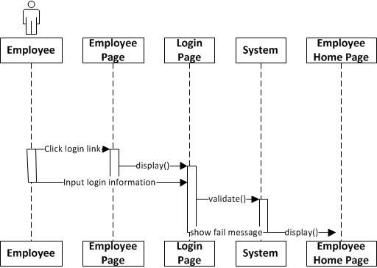

### Log out

|  |  |  |
| --- | --- | --- |
| **Author** | Tran Ngoc Minh Khai | |
| **Use Case Name** | Logout | |
| **Actors** | Employee | |
| **Description** | Employee wants to log out of the System. | |
| **Requirements** |  | |
| **Pre-conditions** | Actor has logged in. | |
| **Post-conditions** | Success: Actor Logged out. | |
| **Basic flow** | Actor Actions:  1. Actor clicks ‘Log out’ link on the Actor’s Home menu.  3. Actor clicks ‘Yes’ button. | System Responses:  2. System show Logout confirmation with two controls :  - ‘Yes’ Button  - ‘No’ Button  4. System redirects to Home page. |
| **Alternative flow** |  |  |
| **Exception** |  |  |

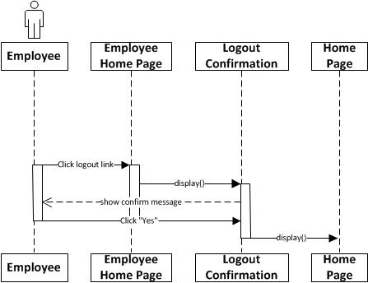

### Retrieve Password

|  |  |  |
| --- | --- | --- |
| **Author** | Tran Ngoc Minh Khai | |
| **Use Case Name** | Retrieve Password | |
| **Actors** | Employee | |
| **Description** | Employee wants to Retrieve password | |
| **Requirements** | Actor provides username and email | |
| **Pre-conditions** | Actor has a account. | |
| **Post-conditions** | Success: User will receive an email’s retrieve password from admin  Fail: Refill information | |
| **Basic flow** | Actor Actions:  1. Actor go to Home page and click ‘Login’ link.  3. Actor click ‘forget password’ link  5. Actor input account information and click ‘Submit’ button | System Responses:  2. System redirects to Login page and displays Login form on the left with the following control:  - ‘UserName’ text field  - ‘Password’ text field  - ‘Login’ button  - ‘forget password’ link  4. System redirects to Retrieve password pageand display Retrieve password form with the following control:  - ‘Username’ text field  - ‘Email’ text field  - ‘Submit’ button  - ‘Cancel’ button  5. System checks the information [Exception 1]  6. System show a message |
| **Alternative flow** | Actor Actions:  [Alternative 1]  1. Actor input the account information and click ‘Submit’ button.  [Alternative 2]  4. Actor click ‘cancel’ button. | System Responses:  2. System checks the information  [Exception 1]  3. System show a message  5. System returns to Login page |
| **Exception** | Actor Actions:  [Exception 1]  1. Actor input invalid username and email. | System Responses:  - System redirect to Retrieve password page with the following controls:  - ‘UserName’ text field  - ‘Email’ text field  - ‘Submit’ button.  - ‘Cancel’ button.  System show a message box: “Invalid Username and Email”. |

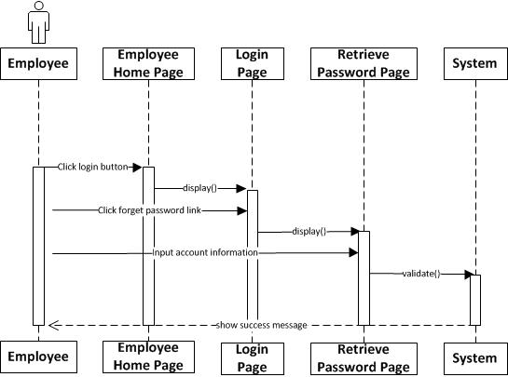

### Edit Profile

|  |  |  |
| --- | --- | --- |
| **Author** | Tran Ngoc Minh Khai | |
| **Use Case Name** | Edit Profile | |
| **Actors** | Employee | |
| **Description** | Employee wants to Edit his/her profile’s information. | |
| **Requirements** | Actor provides profile information | |
| **Pre-conditions** | Actor has logged in. | |
| **Post-conditions** | Success: Profile’s information of this user has been updated.  Fail: Refill information | |
| **Basic flow** | Actor Actions:  1. Actor clicks ‘Profile’ link in Actor’s Home page menu.  3. Actor updates information and click ‘Save’ button. [Alternative 1] | System Responses:  2. System redirects to EditProfile page and displays Edit Profile form with the following control :  - ‘UserName’ text field (read only)  - ‘Old Password’ text field  - ‘New Password’ text field  - ‘New Password Confirm’ text field  -‘EmployeeID’ text field(read only)  - ‘BankName’ text field  -‘BankAccount’ text field  - ‘Birthday’ text field  - ‘Gender’ checkbox group  - ‘Address’ text field  - ‘Phone’ text field  - ‘Email’ text field  - ‘Save’ button  - ‘Back to Home’ button  4. System checks the information  [Exception 1]  5. System update the account into database and then redirects to Actor Home page. |
| **Alternative flow** | Actor Actions:  [Alternative 1]  1. Actor click ‘Back to Home’ button. | System Responses:  2. System returns to Home page. |
| **Exception** | Actor Actions:  [Exception 1]  1. Actor lefts ‘New Password’ text field blank.  2. Actor lefts ‘New Confirm Password’ text field blank.  3. New Password and New Password Confirm don’t match.  4. Actor lefts ‘Name’ text field blank.  5. Actor lefts ‘Birthday’ datebox blank.  6. Input age to ‘Birthday’ datebox less than 16.  7. Actor lefts ‘Address’ text field blank.  8. Actor lefts ‘Phone’ text field blank.  9.Input phone not in numeric or phone length not in range 8 – 14 character.  10. Actor lefts ‘Email’ text field blank or input an invalid email address. | System Responses:  System displays message to Actor :  - ‘Password cannot be blank’’.  - ‘Confirm Password can’t be blank’.  - ‘Confirm password not match Password.’  - ‘Name cannot be blank’.  - ‘Birthday is invalid’.  - ‘Age must over 16’.  - ‘Address cannot be blank’.  - ‘Phone is invalid’.  - ‘The phone number should be numeric only and must be between 8 and 14 digits’.  - ‘Email is invalid’. |

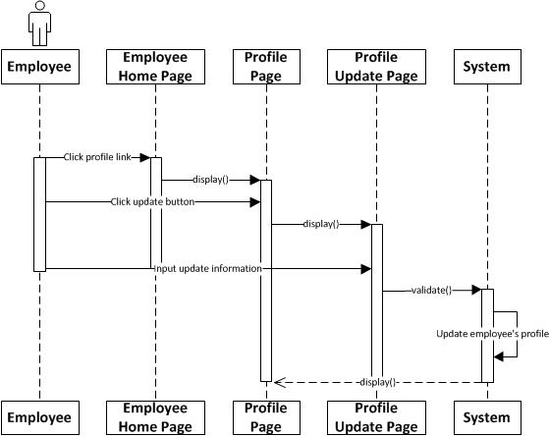

### Create Claim

|  |  |  |
| --- | --- | --- |
| **Author** | Tran Ngoc Minh Khai | |
| **Use Case Name** | Create Claim | |
| **Actors** | Employee | |
| **Description** | Employee wants to create a Claim | |
| **Requirements** | Employee provides Claim’s information | |
| **Pre-conditions** |  | |
| **Post-conditions** | Success: Employee creates a Claim  Fail: Refill information | |
| **Basic flow** | Actor Actions:  1. Actor clicks ‘Claim insurance’ link in Actor’s Home page.  4. Actor inputs Claim’s information and click ‘Register’ Button. [Alternative 1] | System Responses:  2. System redirects to Registration Claim and displays Registration form with the following control :  - ‘ClaimTitle’ text field  - ‘ProductID’ text field  - ‘TotalAmount’ text field  - ‘ReimburseAmount’ text field  - ‘Attachment’ fileupload  -‘Status’  - ‘Register’ button  - ‘Back to Home’ button  5. System checks the information  [Exception 1]  6. System inserts the Claim into database, show message: ‘Your Claim has been created!’ and then redirects to Actor’s home page. |
| **Alternative flow** | Actor Actions:  [Alternative 1]  1. Actor click ‘Back to Home’ button. | System Responses:  2. System returns to Home page. |
| **Exception** | Actor Actions:  [Exception 1]  1. Actor lefts ‘ClaimTitle’ text field blank.  2. Actor lefts ‘ProductID’ text field blank.  3. Actor lefts ‘TotalAmount’ text field blank.  4. Actor lefts ‘ReimburseAmount’ text field blank.  6. Actor lefts ‘Attachment’ fileupload  7. Actor lefts ‘Status’ field | System Responses:  System displays message to Actor :  -‘ ClaimTitle cannot be blank’  -‘ProductID cannot be blank’  -‘ TotalAmount cannot be blank’  -‘ ReimburseAmount cannot be blank’  -‘Attachment hasn’t upload yet ’  -‘Status cannot be blank’ |

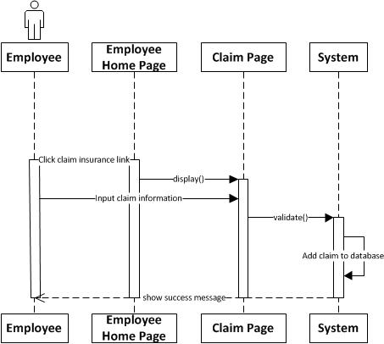

### View Claim

|  |  |  |
| --- | --- | --- |
| **Author** | Tran Ngoc Minh Khai | |
| **Use Case Name** | View Claim | |
| **Actors** | Employee | |
| **Description** | Employee want to view Claim created. | |
| **Requirements** |  | |
| **Pre-conditions** | Actor has logged | |
| **Post-conditions** | Success: Search Claim shows up. | |
| **Basic flow** | Actor Actions:  1. Actor clicks View Claim link on the page.  3. Input search information and click ‘Search’ button | System Responses:  2. System shows the View Claimspagewith the following controls:  - ‘FromDate’ textfield  - ‘ToDate’ textfield  -‘FromAmount’ textfield  -‘ToAmount’ textfiled  -‘Status’ combo box  -‘Search’ button  4. System search information and show search result |
| **Alternative flow** |  |  |
| **Exception** |  |  |

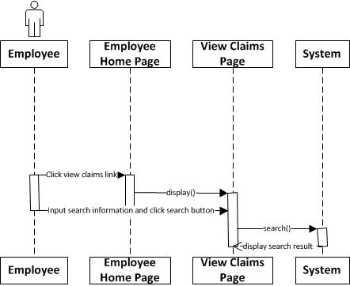

## Administrators



### Login

|  |  |  |
| --- | --- | --- |
| **Author** | Tran Dung Tri | |
| **Use Case Name** | Login | |
| **Actors** | Administrator | |
| **Description** | Administrator wants to login to Admin page | |
| **Requirements** | Actor provides username and password | |
| **Pre-conditions** |  | |
| **Post-conditions** | Success: Administrator logged into website  Fail: Refill information | |
| **Basic flow** | Actor Actions:  1. Actor inputs Admin page URL in Address bar of browser  3. Actor inputs UserName and Password, then click the Login button. [Alternative 1] | System Responses:  2. System redirects to Login page and displays Login form with the following control:  - ‘UserName’ text field  - ‘Password’ text field  - ‘Forgot password’ hyperlink  - ‘Login’ button  4. System checks the information  [Exception 1]  5. System redirects to Admin Home page. |
| **Alternative flow** |  |  |
| **Exception** | Actor Actions:  [Exception 1]  1. ‘UserName’ text field is blank  2. ‘Password’ text field is blank | System Responses:  System displays message to Guest :  - ‘UserName cannot be blank’  - ‘Password cannot be blank’ |



### Logout

|  |  |  |
| --- | --- | --- |
| **Author** | Tran Dung Tri | |
| **Use Case Name** | Logout | |
| **Actors** | Administrator | |
| **Description** | Administrator wants to log out of the System | |
| **Requirements** |  | |
| **Pre-conditions** | Actor has logged in | |
| **Post-conditions** | Success: Actor Logged out | |
| **Basic flow** | Actor Actions:  1. Actor clicks ‘Log out’ button on the Actor’s Home menu. | System Responses:  2. System redirects to Logout page, removes session, and then redirects to Login page |
| **Alternative flow** |  |  |
| **Exception** |  |  |



### Retrieve Password

|  |  |  |  |
| --- | --- | --- | --- |
| **Author** | Tran Dung Tri | | |
| **Use Case Name** | Retrieve Password | | |
| **Actors** | Administrator | | |
| **Description** | Administrator forgets and wants to get password | | |
| **Requirements** | Actor provides username | | |
| **Pre-conditions** |  | | |
| **Post-conditions** | Success: The password of Administrator is sent to email  Fail: Refill information | | |
| **Basic flow** | | Actor Actions:  1. Actor inputs Admin page URL in Address bar of browser  3. Actor clicks ‘Forgot password’ hyperlink.  5. Actor inputs username and clicks ‘Retrieve password’ button  [Alternative 1] | System Responses:  2. System redirects to Login page and displays Login form with the following control:  - ‘UserName’ text field  - ‘Password’ text field  - ‘Forgot password’ hyperlink  - ‘Login’ button  4. System redirects to ‘Retrieve password’ page  6. System checks the information  [Exception 1]  7. System sends email to Administrator |
| **Alternative flow** | | [Alternative 1]  1. Actor clicks ‘Cancel’ button. | 1. System redirects to ‘Login’ page. |
| **Exception** | | Actor Actions:  [Exception 1]  1. ‘UserName’ text field is blank | System Responses:  1. System displays message to Guest :  - ‘UserName cannot be blank’ |



### Manage Account



#### View Account List

|  |  |  |
| --- | --- | --- |
| **Author** | Tran Dung Tri | |
| **Use Case Name** | View Account List | |
| **Actors** | Administrator | |
| **Description** | Administrator wants to view list of accounts | |
| **Requirements** |  | |
| **Pre-conditions** | Actor has logged in as Administrator | |
| **Post-conditions** | Success: Account list is successfully shown | |
| **Basic flow** | Actor Actions:  1. Actor clicks ‘Managing Account’ button on Admin page | System Responses:  2. System redirects to View Account List page and displays form for Actor :  -‘UserName’ text field  -‘Password’ password field  -‘EmployeeID’ dropdown list  -‘AccountCode’ text field  -‘Address’ text field  -‘Email’ text field  -‘PhoneNo’ text field  -‘BankName’ text field  -‘BankAccount’ text field  -‘Modify’ button  -‘Delete’ button  -‘Search’ button  [Alternative 1] [Alternative 2] [Alternative 3] |
| **Alternative flow** | Actor Actions:  [Alternative 1]  Actor clicks ‘Modify’ button on View Account List page  [Alternative 2]  Actor clicks ‘Delete’ button on View Account List page  [Alternative 3]  Actor clicks Search button on View Account List page | System Responses:  System redirects to ModifyAccount page  System redirects to DeleteAccount page  System redirects toSearch Account page |
| **Exceptions** |  |  |



#### Modify Account

|  |  |  |
| --- | --- | --- |
| **Author** | Tran Dung Tri | |
| **Use Case Name** | Modify Account | |
| **Actors** | Administrator | |
| **Description** | Administrator wants to modify Account | |
| **Requirements** | Actor must choose Account to modify | |
| **Pre-conditions** | Actor has logged in as Administrator | |
| **Post-conditions** | Success: Modify Account successfully  Fail: Refill information | |
| **Basic flow** | Actor Actions:  1. Actor clicks Modify button on View list of Accounts page  3. Actor changes any information  5. Actor click ‘Modify’ button.  [Alternative 1] | System Responses:  2. System redirects to this page and displays form for Actor to input information with the following controls :  -‘UserName’ text field  -‘Password’ password field  -‘EmployeeID’ dropdown list  -‘AccountCode’ text field  -‘Address’ text field  -‘Email’ text field  -‘PhoneNo’ text field  -‘BankName’ text field  -‘BankAccount’ text field  -‘Modify’ button  -‘Cancel’ button  System fills all information  UserName, Password, EmloyeeID, AccountCodefor Account are read-only  4. System checks information input [Exception1]  6. System updatesAccount into database then display message ‘Your Account has been successfully updated’ |
| **Alternative flow** | Actor Actions:  [Alternative 1]  Actor click ‘Cancel’ button | System Response:  System redirects to View Account List page. |
| **Exceptions** | Actor Actions:  [Exception1]  1. One of fields is blank  2. Password cannot be the same as previous password  3. Wrong email | System Response:  1. System displays message to notice  2. System displays message to notice inputting another password  3. System displays message to notice inputting correct email |



#### Delete Account

|  |  |  |
| --- | --- | --- |
| **Author** | Tran Dung Tri | |
| **Use Case Name** | Delete Account | |
| **Actors** | Administrator | |
| **Description** | Administrator wants to delete Account | |
| **Requirements** | Actor must choose Account to delete | |
| **Pre-conditions** | Actor has logged in as Administrator | |
| **Post-conditions** | Success: Delete Account successfully  Fail: Error Page shown | |
| **Basic flow** | Actor Actions:  1. Actor clicks Delete button on View Account List page  3. Actor clicks Yes button on popup message  [Alternative 1] | System Responses:  2. System show popup message:”Do you want to delete Account:” + Account name. With Yes and No button  4. System deactivatesAccount by setting ‘isActive’ property to false, then display message ‘Account has been successfully deleted’. |
| **Alternative flow** | Actor Actions:  [Alternative 1]  Actor clicks No button on popup message | System Responses:  System returns to current page. |
| **Exceptions** |  |  |



#### Search Account

|  |  |  |
| --- | --- | --- |
| **Author** | Tran Dung Tri | |
| **Use Case Name** | Search Account | |
| **Actors** | Administrator | |
| **Description** | Administrator wants to search an Account | |
| **Requirements** | Actor provides search information | |
| **Pre-conditions** | Actor has logged in as Administrator | |
| **Post-conditions** | Success: Properties match the condition show up.  Fail: Do not have any property match the condition. | |
| **Basic flow** | Actor Actions:  1. Actor clicks ‘Search’ button on the View Account List page.  3. Actor inputs searching’s information and click ‘Search’ button  [Alternative 1] | System Responses:  2. System show the Search contains the following controls:  -‘SearchOption’ radio button: by EmployeeID or UserName  -Text field for ‘EmployeeID’ or ‘UserName’ searching  - ‘Search’ button  - ‘Reset’ button  4. System selects the properties in database that match searching condition and displays the result in the Searching Result list  If all text fields are blank, system displays all accounts |
| **Alternative flow** | Actor Actions:  [Alternative 1]  Actor clicks Reset button | System Responses:  System clears all text fields, resets radio button |
| **Exception** |  |  |



### Manage News



#### Add News

|  |  |  |
| --- | --- | --- |
| **Author** | Tran Ngoc Minh Khai | |
| **Use case name** | Add News | |
| **Actors** | Administrator | |
| **Description** | Administrator want to add a News | |
| **Requirements** |  | |
| **Pre-conditions** | Already login into the System as Administrator | |
| **Post-conditions** | Success: A News is added into the database.  Fail: Refill information | |
| **Basic flow** | Actor actions:  1. From Admin page, actor clicks on to the ‘Add News’ link.  3. Actor:   * Inputs all information into Add News form * Clicks on to ‘Add News’ button to finish adding. [Alternative 1] [Alternative 2] | System response:  2. System redirects to ‘Add News’ page and display form with the following controls:  - ‘Title’ textfield.  - ‘Date’ textfield.  - ‘ShortContent’ textfield.  - ‘LongContent’ textfiled  - ‘Author’ textfield  - ‘Add News’ button  - ‘Clear’ button  - ‘Cancel’ button  4. System checks information.  [Exception 1]  5. System insert News into database and show success message, then redirects to Admin’s home page. |
| **Alternative flow** | [Alternative 1]  1. Actor clicks on to ‘Cancel’ button  [Alternative 2]  1. Actor clicks on to ‘Clear’ button | 1. System redirects to ‘View List of News’ page  2. All field will clear |
| **Exception** | [Exception 1]  1. Actor lefts ‘Title’’ textfield.  2. Actor lefts ‘Date’ textfield.  3. Actor lefts ‘ShortContent’ textfield.  4. Actor lefts ‘LongContent’ textfield.  5. Actor lefts ‘Author’ textfield. | System displays a message to notice actor:  “Title cannot be blank. Please input Title.”  “Date cannot be blank. Please input Date.”  “ShortContent cannot be blank. Please input ShortContent.  ”LongContent cannot be blank. Please input LongContent.”  “Author cannot be blank. Please input Author.” |

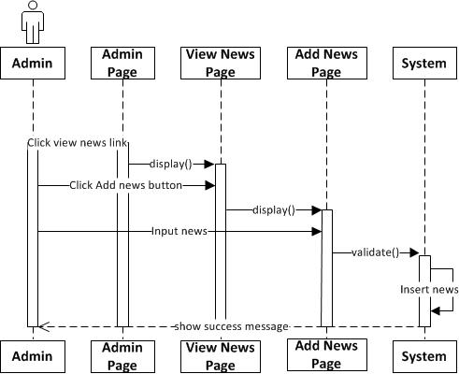

#### Edit News

|  |  |  |
| --- | --- | --- |
| **Author** | Tran Ngoc Minh Khai | |
| **Use case name** | Edit News | |
| **Actors** | Administrator | |
| **Description** | Administrator want to edit a news | |
| **Requirements** |  | |
| **Pre-conditions** | Already login into the System as Administrator | |
| **Post-conditions** | Success: A News is edited in the database. | |
| **Basic flow** | Actor actions:  1. From Admin page, actor clicks on to the ‘View news’ link  3. Actor clicks ‘Edit News’ button  5. Actor:   * Edit information and clicks on to ‘Update’ button to finish editing. [Alternative 1] | System response:  2. System redirects to ‘View news’ page  4. System redirects to ‘Edit news’ page and displays Edit news form with the following control :  - ‘Title’ textfield.  - ‘Date’ textfield.  - ‘ShortContent’ textfield.  - ‘LongContent’ textfiled  - ‘Author’ textfield  - ‘Edit news’ button  - ‘Cancel’ button  6. System checks information.  [Exception 1]  7. System update news into database and the show success message. |
| **Alternative flow** | [Alternative 1]  1. Actor clicks on to ‘Cancel’ button | 1. System redirects to ‘View List of News’ page |
| **Exception** | [Exception 1]  1. Actor lefts ‘Title’’ textfield.  2. Actor lefts ‘Date’ textfield.  3. Actor lefts ‘ShortContent’ textfield.  4. Actor lefts ‘LongContent’ textfield.  5. Actor lefts ‘Author’ textfield. | System displays a message to notice actor:  “Title cannot be blank. Please input Title.”  “Date cannot be blank. Please input Date.”  “ShortContent cannot be blank. Please input ShortContent.  ”LongContent cannot be blank. Please input LongContent.”  “Author cannot be blank. Please input Author.” |

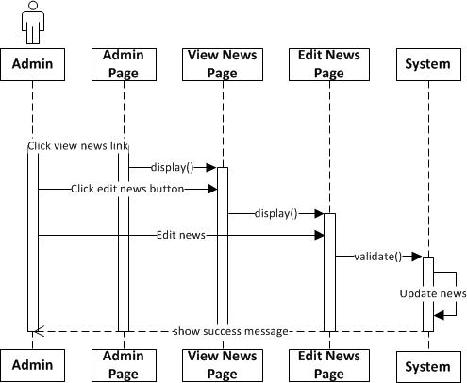

#### Search News

|  |  |  |
| --- | --- | --- |
| **Author** | Tran Ngoc Minh Khai | |
| **Use Case Name** | Search News | |
| **Actors** | Administrator | |
| **Description** | Administrator want to search news | |
| **Requirements** |  | |
| **Pre-conditions** | Actor has logged | |
| **Post-conditions** | Success: Search news shows up | |
| **Basic flow** | Actor Actions:  1. Actor clicks View News link on the page.  3. Input search information and click ‘Search’ button | System Responses:  2. System shows the View News page with the following controls:  - ‘content’ field  -‘Search’ button  4. System search information and show search result |
| **Alternative flow** |  |  |
| **Exception** |  |  |

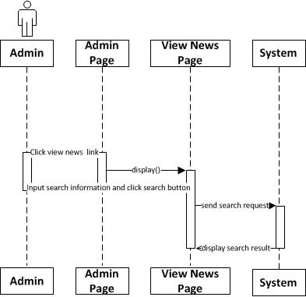

#### Delete news

|  |  |  |
| --- | --- | --- |
| **Author** | Tran Ngoc Minh Khai | |
| **Use case name** | Delete news | |
| **Actors** | Administrator | |
| **Description** | Administrator wants to Delete news | |
| **Requirements** |  | |
| **Pre-conditions** | Actor has logged in as Admin | |
| **Post-conditions** | Success: News removed form list of news  Failed: Refill information | |
| **Basic flow** | Actor actions:  1 Actor click ‘view news’ link from admin page  3. From list of News page, actor clicks on Delete button to Delete News.  5. Actor click Yes button to delete. [Alternative 1] | System response:  2. System redirects to View news page  4. System Display Message:” Do you want to delete this News? ”.  6. System removes this news from list of newss and update information into database. |
| **Alternative flow** | Actor actions:  [Alternative 1]  Actor click No button | System response:  System redirects to current page and this news is not removed. |
| **Exception** |  |  |

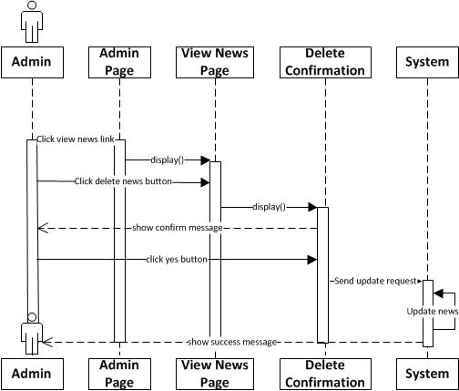

#### Restore news

|  |  |  |
| --- | --- | --- |
| **Author** | Tran Ngoc Minh Khai | |
| **Use case name** | Retore news | |
| **Actors** | Administrator | |
| **Description** | Administrator wants to Restore news deleted | |
| **Requirements** |  | |
| **Pre-conditions** | Actor has logged in as Admin | |
| **Post-conditions** | Success: News( removed) will be restored. | |
| **Basic flow** | Actor actions:  1 Actor click ‘view news’ link from admin page and then click ‘trash’ button  3. Actor clicks on ‘Restore’ button to restore News(removed). | System response:  2. System redirects to View news page with following control :  - ‘Restore’ button  4. System update news and show success message |
| **Alternative flow** |  |  |
| **Exception** |  |  |

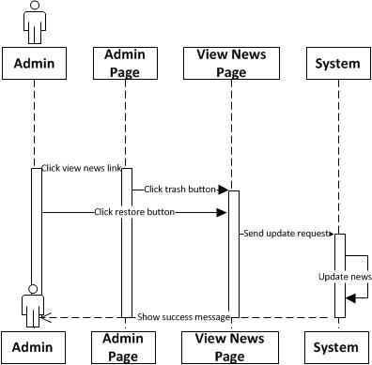

### Manage Contact



#### Search contact

|  |  |  |
| --- | --- | --- |
| **Author** | Tran Minh Duc | |
| **Use case name** | Search Contact | |
| **Actors** | Administrator | |
| **Description** | Search Contact | |
| **Requirements** |  | |
| **Pre-conditions** | Actor has already logged into the System as Administrator | |
| **Post-conditions** | Success: Show contact’s result | |
| **Basic flow** | Actor actions:  1. From ‘Admin’ page, actor clicks on to a ‘View Contact’ hyperlink.  3. Actor inputs property type information :  - Provide the contact’s name in ‘FeedbackID’ text field.  .5.Actor click ‘Search’ button. | System response:  2. System redirects to ‘View Contact ‘page and display list of Contact in table form:   * FeedbackID. * FeedbackTitle * FeedbackContent * SenderEmail * DateSent * isActive   4. System checks information input [Exception 1]  6. System redirects to ‘View Contact ‘page and display Contact information:   * FeedbackID. * FeedbackTitle * FeedbackContent * SenderEmail * DateSent * isActive |
| **Alternative flow** |  |  |
| **Exception** | Actor Actions:  [Exception 1]  1.Admin left ‘FeedbackID’ text field blank  2. Length of name >50 char  3. Value in ‘Name’ text field has been in database | System Response:  .System displays message to notice seller: ‘FeedbackID of bank can’t be blank. Please enter FeebackID for bank.’  . System displays message to notice seller: ‘Length of contact’s FeedbackID can’t be large than 50 char.’  . System displays message to notice seller: ‘FeedbackID of bank has been in database. Please check and enter another FeedBackID.’ |

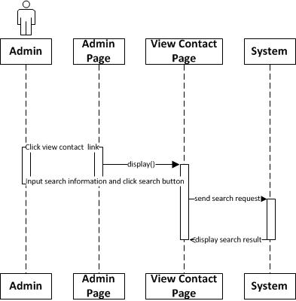

#### Delete Contact

|  |  |  |
| --- | --- | --- |
| **Author** | Tran Minh Duc | |
| **Use case name** | Search Contact | |
| **Actors** | Administrator | |
| **Description** | Delete an Contact | |
| **Requirements** | Actor provides Contact information | |
| **Pre-conditions** | Actor has already logged into the System as Administrator | |
| **Post-conditions** | Success: An Contact is deleted in View Contact page. | |
| **Basic flow** | Actor actions:  Actor actions:   1. From ‘Admin’ page, actor clicks on to a ‘View Contact’ hyperlink.   2. Actor clicks ‘Delete’ button  4. Actor clicks ‘Yes’ button.[Alternative 1] | System response:  2. System redirects to ‘View Contact ‘page and display list of Contact in table form:   * FeedbackID. * FeedbackTitle * FeedbackContent * SenderEmail * DateSent * isActive   3. A confirms message box appears:”Do you want to delete this contact?”  5. System checks input information.  [Exception 1]  6. System update the contact in the database.  7. Show success message |
| **Alternative flow** | [Alternative 1]  1. Actor clicks on to ‘No’ button | . System redirects to ‘View Contact’ page |
| **Exception** |  |  |

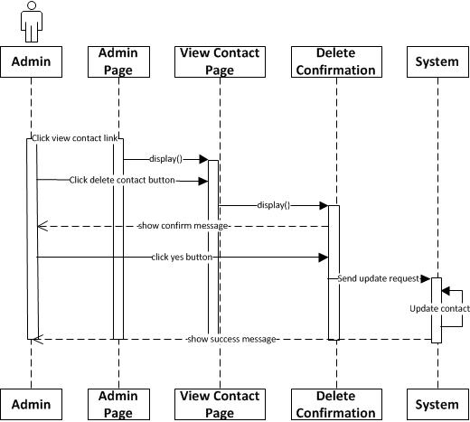

#### Restore Contact

|  |  |  |
| --- | --- | --- |
| **Author** | Tran Minh Duc | |
| **Use case name** | Restore Contact | |
| **Actors** | Administrator | |
| **Description** | Restore an Contact | |
| **Requirements** | Actor provides Contact information | |
| **Pre-conditions** | Actor has already logged into the System as Administrator | |
| **Post-conditions** | Success: A Contact is restored in View Contact page. | |
| **Basic flow** | Actor actions:  Actor actions:  1.From ‘Admin’ page, actor clicks on to a ‘View Contact’ hyperlink.  3.Form ‘View Contact’ page, actor clicks on to a ‘Trash’ button  5. Actor clicks ‘Restore’ button.[Alternative 1] | System response:  2. System redirects to ‘View Contact ‘page and display list of Contact in table form:   * FeedbackID. * FeedbackTitle * FeedbackContent * SenderEmail * DateSent * isActive   4. System redirects to ‘View Contact ‘page and display list of Contact information in trash  6. A confirms message box appears:”Do you want to restore this contact?”  7. System update the contact in the database.  8. Show success message |
| **Alternative flow** | [Alternative 1]  1. Actor clicks on to ‘No’ button | 2 System redirects to ‘View Contact’ page |
| **Exception** |  |  |

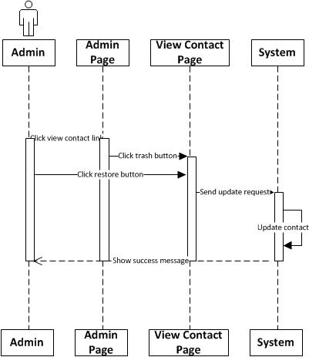

### Manage Claim



#### View Claim List

|  |  |  |
| --- | --- | --- |
| **Author** | Tran Dung Tri | |
| **Use Case Name** | View Claim List | |
| **Actors** | Administrator | |
| **Description** | Administrator wants to view list of claims | |
| **Requirements** |  | |
| **Pre-conditions** | Actor has logged in as Administrator | |
| **Post-conditions** | Success: Claim list is successfully shown | |
| **Basic flow** | Actor Actions:  1. Actor clicks ‘Managing Claim’ button on Admin page | System Responses:  2. System redirects to View Claim List page and displays form for Actor :  -‘ClaimID’ text field  -‘ClaimTitle’ text field  -‘EmployeeID’ dropdown list  -‘ProductID’ text field  -‘TotalAmount’ text field  -‘ReimburseAmount’ text field  -‘Attachment’ file download  -‘Status’ dropdown list  -‘Modify’ button  -‘Delete’ button  -‘Search’ button  [Alternative 1] [Alternative 2] [Alternative 3] |
| **Alternative flow** | Actor Actions:  [Alternative 2]  Actor clicks ‘Approve/Deny’ button on View Claim List page  [Alternative 3]  Actor clicks ‘Delete’ button on View Claim List page  [Alternative 4]  Actor clicks Search button on View Claim List page | System Responses:  System redirects toApprove/DenyClaim page  System redirects to DeleteClaim page  System redirects to Search Claim page |
| **Exceptions** |  |  |



#### Approve/DenyClaim

|  |  |  |
| --- | --- | --- |
| **Author** | Tran Dung Tri | |
| **Use Case Name** | Modify Claim | |
| **Actors** | Administrator | |
| **Description** | Administrator wants to modify Claim | |
| **Requirements** | Actor must choose Claim to modify | |
| **Pre-conditions** | Actor has logged in as Administrator | |
| **Post-conditions** | Success: Modify Claim successfully  Fail: Refill information | |
| **Basic flow** | Actor Actions:  1. Actor clicks Modify button on View list of Claims page  3. Actor changes Status  5. Actor clicks ‘Approve’ or ‘Deny’ button.  [Alternative 1] | System Responses:  2. System redirects to this page and displays form for Actor to input information with the following controls :  -‘ClaimID’ text field  -‘ClaimTitle’ text field  -‘EmployeeID’ dropdown list  -‘ProductID’ text field  -‘TotalAmount’ text field  -‘ReimburseAmount’ text field  -‘Attachment’ file download  -‘ClaimDate’ date field  -‘Status’ dropdown list  -‘Modify’ button  -‘Cancel’ button  System fills all information  All controls are read-only, except Status  4. System checks information input  6. System updatesClaim into database then display message ‘Your Claim has been successfully updated’ |
| **Alternative flow** | Actor Actions:  [Alternative 1]  Actor click ‘Cancel’ button | System Response:  System redirects to View Claim List page. |
| **Exceptions** |  |  |





#### Delete Claim

|  |  |  |
| --- | --- | --- |
| **Author** | Tran Dung Tri | |
| **Use Case Name** | Delete Claim | |
| **Actors** | Administrator | |
| **Description** | Administrator wants to delete Claim | |
| **Requirements** | Actor must choose Claim to delete | |
| **Pre-conditions** | Actor has logged in as Administrator | |
| **Post-conditions** | Success: Delete Claim successfully  Fail: Error Page shown | |
| **Basic flow** | Actor Actions:  1. Actor clicks Delete button on View Claim List page  3. Actor clicks Yes button on popup message  [Alternative 1] | System Responses:  2. System show popup message:”Do you want to delete Claim:” + Claim name. With Yes and No button  4. System deactivatesClaim by setting ‘isActive’ property to false then display message ‘Claim has been successfully deleted’. |
| **Alternative flow** | Actor Actions:  [Alternative 1]  Actor clicks No button on popup message | System Responses:  System returns to current page. |
| **Exceptions** |  |  |



#### Search Claim

|  |  |  |
| --- | --- | --- |
| **Author** | Tran Dung Tri | |
| **Use Case Name** | Search Claim | |
| **Actors** | Administrator | |
| **Description** | Administrator wants to search aClaim | |
| **Requirements** | Actor provides search information | |
| **Pre-conditions** | Actor has logged in as Administrator | |
| **Post-conditions** | Success: Properties match the condition show up.  Fail: Do not have any property match the condition. | |
| **Basic flow** | Actor Actions:  1. Actor clicks ‘Search’ button on the View Claim List page.  3. Actor inputs searching’s information and click ‘Search’ button’  [Alternative 1] | System Responses:  2. System show the Search contains the following controls:  - ‘SearchOption’ radio button: search by ‘ClaimID’ or ‘EmployeeID’  -Text field for ‘ClaimID’ or ‘EmployeeID’ searching  -‘Status’ dropdown list  -‘FromDate’ date field  -‘ToDate’ date field  - ‘Search’ button  -‘Reset’ button  4. System selects the properties in database that match searching condition and displays the result in the Searching Result list  If all fields are blank, system displays all claims  [Exception 1] |
| **Alternative flow** | Actor Actions:  [Alternative 1]  Actor click ‘Reset’ button | System Responses:  System clears all text field and date fields, resets radio button |
| **Exception** | Actor Actions:  [Exception1]  1. ‘FromDate’ value is greater than ‘ToDate’ value | System Response:  1. System displays message to notice for inputting again ‘FromDate’ and ‘ToDate’ |



### Manage Employee



#### View Employee List

|  |  |  |
| --- | --- | --- |
| **Author** | Tran Dung Tri | |
| **Use Case Name** | View Employee List | |
| **Actors** | Administrator | |
| **Description** | Administrator wants to view list of Employees | |
| **Requirements** |  | |
| **Pre-conditions** | Actor has logged in as Administrator | |
| **Post-conditions** | Success: Employee list is successfully shown | |
| **Basic flow** | Actor Actions:  1. Actor clicks ‘Managing Employee’ button on Admin page | System Responses:  2. System redirects to View Employee List page and displays form for Actor :  -‘EmployeeID’ text field  -‘EmployeeName’ text field  -‘AccountCode’ text field  -‘EmployeeTitle’ text field  -‘Address’ text field  -‘Email’ text field  -‘PhoneNumber’ text field  -‘BankName’ text field  -‘BankAccount’ text field  -‘Add’ button  -‘Modify’ button  -‘Delete’ button  -‘Search’ button  [Alternative 1] [Alternative 2] [Alternative 3] [Alternative 4] |
| **Alternative flow** | Actor Actions:  [Alternative 1]  Actor clicks ‘Add’ button on View Employee List page  [Alternative 2]  Actor clicks ‘Modify’ button on View Employee List page  [Alternative 3]  Actor clicks ‘Delete’ button on View Employee List page  [Alternative 4]  Actor clicks Search button on View Employee List page | System Responses:  System redirects to AddEmployee page  System redirects to ModifyEmployee page  System redirects to DeleteEmployee page  System redirects to Search Employee page |
| **Exceptions** |  |  |



#### AddEmployee

|  |  |  |
| --- | --- | --- |
| **Author** | Tran Dung Tri | |
| **Use Case Name** | Add newEmployee | |
| **Actors** | Administrator | |
| **Description** | Administrator wants to add newEmployee | |
| **Requirements** |  | |
| **Pre-conditions** | Actor has logged in as Administrator | |
| **Post-conditions** | Success: Add newEmployee successfully  Fail: Refill information | |
| **Basic flow** | Actor Actions:  1. Actor clicks ‘Add’ button on View list of Employees page  3. Actor inputs all information  5. Actor click ‘Add’ button.  [Alternative 1] [Alternative 2] | System Responses:  2. System redirects to ‘Add’ page and displays form for Actor to input information with the following controls:  -‘EmployeeID’ text field (system fills automatically)  -‘EmployeeName’ text field  -‘AccountCode’ text field (randomly generated)  -‘EmployeeTitle’ dropdown list  -‘Address’ text field  -‘Email’ text field  -‘PhoneNumber’ text field  -‘BankName’ text field  -‘BankAccount’ text field  -‘Add’ button  -‘Reset’ button  -‘Back to home page’ button  4. System checks information input [Exception1]  6. System insertsEmployee into database then display message ‘Your Employee has been successfully inserted’ |
| **Alternative flow** | Actor Actions:  [Alternative 1]  Actor click ‘Reset’ button  [Alternative 2]  Actor click ‘Back to home page’ button | System Response:  System resets all fields to default values  System redirects to View Employee List page. |
| **Exceptions** | Actor Actions:  [Exception1]  1. One of fields is blank  2. EmployeeID cannot be the same as existing  3. Wrong email | System Response:  1. System displays message to notice  2. System displays message to notice inputting another EmployeeID  3. System displays message to notice inputting correct email |



#### Modify Employee

|  |  |  |
| --- | --- | --- |
| **Author** | Tran Dung Tri | |
| **Use Case Name** | Modify Employee | |
| **Actors** | Administrator | |
| **Description** | Administrator wants to modify Employee | |
| **Requirements** | Actor must choose Employee to modify | |
| **Pre-conditions** | Actor has logged in as Administrator | |
| **Post-conditions** | Success: Modify Employee successfully  Fail: Refill information | |
| **Basic flow** | Actor Actions:  1. Actor clicks Modify button on View list of Employees page  3. Actor changes any information  5. Actor click ‘Modify’ button.  [Alternative 1] | System Responses:  2. System redirects to this page and displays form for Actor to input information with the following controls :  -‘EmployeeID’ text field (read only)  -‘EmployeeName’ text field  -‘AccountCode’ text field (read only)  -‘EmployeeTitle’ text field  -‘Address’ text field  -‘Email’ text field  -‘PhoneNumber’ text field  -‘BankName’ text field  -‘BankAccount’ text field  -‘Modify’ button  -‘Cancel’ button  4. System checks information input [Exception1]  6. System updatesEmployee into database then display message ‘Your Employee has been successfully updated’ |
| **Alternative flow** | Actor Actions:  [Alternative 1]  Actor click ‘Cancel’ button | System Response:  System redirects to View Employee List page. |
| **Exceptions** | Actor Actions:  [Exception1]  1. One of fields is blank  2. Wrong email | System Response:  1. System displays message to notice  2. System displays message to notice inputting correct email |



#### Delete Employee

|  |  |  |
| --- | --- | --- |
| **Author** | Tran Dung Tri | |
| **Use Case Name** | Delete Employee | |
| **Actors** | Administrator | |
| **Description** | Administrator wants to delete Employee | |
| **Requirements** | Actor must choose Employee to delete | |
| **Pre-conditions** | Actor has logged in as Administrator | |
| **Post-conditions** | Success: Delete Employee successfully  Fail: Error Page shown | |
| **Basic flow** | Actor Actions:  1. Actor clicks Delete button on View Employee List page  3. Actor clicks Yes button on popup message  [Alternative 1] | System Responses:  2. System show popup message:”Do you want to delete Employee:” + Employee name. With Yes and No button  4. System deactivatesEmployee by setting ‘isActive’ property to false, then display message ‘Employee has been successfully deleted’. |
| **Alternative flow** | Actor Actions:  [Alternative 1]  Actor clicks No button on popup message | System Responses:  System returns to current page. |
| **Exceptions** |  |  |



#### Search Employee

|  |  |  |
| --- | --- | --- |
| **Author** | Tran Dung Tri | |
| **Use Case Name** | Search Employee | |
| **Actors** | Administrator | |
| **Description** | Administrator wants to search an Employee | |
| **Requirements** | Actor provides search information | |
| **Pre-conditions** | Actor has logged in as Administrator | |
| **Post-conditions** | Success: Properties match the condition show up.  Fail: Do not have any property match the condition. | |
| **Basic flow** | Actor Actions:  1. Actor clicks ‘Search’ button on the View Employee List page.  3. Actor inputs searching’s information and click ‘Search’ button  [Alternative 1] | System Responses:  2. System show the Search contains the following controls:  -‘SearchOption’ radio button: by EmployeeID or EmployeeName  -Text field for ‘EmployeeID’ or ‘EmployeeName’ searching  -‘EmployeeTitle’ dropdown list  - ‘Search’ button  - ‘Reset’ button  4. System selects the properties in database that match searching condition and displays the result in the Searching Result list  If all text fields are blank, system displays all Employees |
| **Alternative flow** | Actor Actions:  [Alternative 1]  Actor clicks Reset button | System Responses:  System clears all text fields, resets radio button |
| **Exception** |  |  |



### Manage Insurance Product



#### View Insurance Product List

|  |  |  |
| --- | --- | --- |
| **Author** | Tran Dung Tri | |
| **Use Case Name** | View Insurance Product List | |
| **Actors** | Administrator | |
| **Description** | Administrator wants to view list of Insurance Products | |
| **Requirements** |  | |
| **Pre-conditions** | Actor has logged in as Administrator | |
| **Post-conditions** | Success: Insurance Product list is successfully shown | |
| **Basic flow** | Actor Actions:  1. Actor clicks ‘Managing Insurance Product’ button on Admin page | System Responses:  2. System redirects to View Insurance Product List page and displays form for Actor :  -‘ProductID’ text field  -‘ProductName’ text field  -‘MaxAmount’ text field  -‘DateCreated’ date field  -‘Description’ text field  -‘Add’ button  -‘Modify’ button  -‘Delete’ button  -‘Search’ button  [Alternative 1] [Alternative 2] [Alternative 3] [Alternative 4] |
| **Alternative flow** | Actor Actions:  [Alternative 1]  Actor clicks ‘Add’ button on View Insurance Product List page  [Alternative 2]  Actor clicks ‘Modify’ button on View Insurance Product List page  [Alternative 3]  Actor clicks ‘Delete’ button on View Insurance Product List page  [Alternative 4]  Actor clicks Search button on View Insurance Product List page | System Responses:  System redirects to AddInsurance Product page  System redirects to ModifyInsurance Product page  System redirects to DeleteInsurance Product page  System redirects to Search Insurance Product page |
| **Exceptions** |  |  |



#### AddInsurance Product

|  |  |  |
| --- | --- | --- |
| **Author** | Tran Dung Tri | |
| **Use Case Name** | Add newInsurance Product | |
| **Actors** | Administrator | |
| **Description** | Administrator wants to add newInsurance Product | |
| **Requirements** |  | |
| **Pre-conditions** | Actor has logged in as Administrator | |
| **Post-conditions** | Success: Add newInsurance Product successfully  Fail: Refill information | |
| **Basic flow** | Actor Actions:  1. Actor clicks ‘Add’ button on View list of Insurance Products page  3. Actor inputs all information  5. Actor click ‘Add’ button.  [Alternative 1] [Alternative 2] | System Responses:  2. System redirects to ‘Add’ page and displays form for Actor to input information with the following controls:  -‘ProductID’ text field (system fills automatically)  -‘ProductName’ text field  -‘MaxAmount’ text field  -‘DateCreated’ date field (system fills automatically)  -‘Description’ text field  -‘Add’ button  -‘Reset’ button  -‘Back to home page’ button  4. System checks information input [Exception1]  6. System insertsInsurance Product into database then display message ‘Your Insurance Product has been successfully inserted’ |
| **Alternative flow** | Actor Actions:  [Alternative 1]  Actor click ‘Reset’ button  [Alternative 2]  Actor click ‘Back to home page’ button | System Response:  System resets all fields to default values  System redirects to View Insurance Product List page. |
| **Exceptions** | Actor Actions:  [Exception1]  1. One of fields is blank  2. Insurance ProductID cannot be the same as existing | System Response:  1. System displays message to notice  2. System displays message to notice inputting another ProductID |



#### Modify Insurance Product

|  |  |  |
| --- | --- | --- |
| **Author** | Tran Dung Tri | |
| **Use Case Name** | Modify Insurance Product | |
| **Actors** | Administrator | |
| **Description** | Administrator wants to modify Insurance Product | |
| **Requirements** | Actor must choose Insurance Product to modify | |
| **Pre-conditions** | Actor has logged in as Administrator | |
| **Post-conditions** | Success: Modify Insurance Product successfully  Fail: Refill information | |
| **Basic flow** | Actor Actions:  1. Actor clicks Modify button on View list of Insurance Products page  3. Actor changes any information  5. Actor click ‘Modify’ button.  [Alternative 1] | System Responses:  2. System redirects to this page and displays form for Actor to input information with the following controls :  -‘ProductID’ text field  -‘ProductName’ text field  -‘MaxAmount’ text field  -‘DateCreated’ date field  -‘Description’ text field  -‘Modify’ button  -‘Cancel’ button  System fills all information  4. System checks information input [Exception1]  6. System updatesInsurance Product into database then display message ‘Your Insurance Product has been successfully updated’ |
| **Alternative flow** | Actor Actions:  [Alternative 1]  Actor click ‘Cancel’ button | System Response:  System redirects to View Insurance Product List page. |
| **Exceptions** | Actor Actions:  [Exception1]  1. One of fields is blank | System Response:  1. System displays message to notice |



#### Delete Insurance Product

|  |  |  |
| --- | --- | --- |
| **Author** | Tran Dung Tri | |
| **Use Case Name** | Delete Insurance Product | |
| **Actors** | Administrator | |
| **Description** | Administrator wants to delete Insurance Product | |
| **Requirements** | Actor must choose Insurance Product to delete | |
| **Pre-conditions** | Actor has logged in as Administrator | |
| **Post-conditions** | Success: Delete Insurance Product successfully  Fail: Error Page shown | |
| **Basic flow** | Actor Actions:  1. Actor clicks Delete button on View Insurance Product List page  3. Actor clicks Yes button on popup message  [Alternative 1] | System Responses:  2. System show popup message:”Do you want to delete Insurance Product:” + Insurance Product name with Yes and No button  4. System deactivatesInsurance Product by setting ‘isActive’ property to false, then display message ‘Insurance Product has been successfully deleted’. |
| **Alternative flow** | Actor Actions:  [Alternative 1]  Actor clicks No button on popup message | System Responses:  System returns to current page. |
| **Exceptions** |  |  |



#### Search Insurance Product

|  |  |  |
| --- | --- | --- |
| **Author** | Tran Dung Tri | |
| **Use Case Name** | Search Insurance Product | |
| **Actors** | Administrator | |
| **Description** | Administrator wants to search an Insurance Product | |
| **Requirements** | Actor provides search information | |
| **Pre-conditions** | Actor has logged in as Administrator | |
| **Post-conditions** | Success: Properties match the condition show up.  Fail: Do not have any property match the condition. | |
| **Basic flow** | Actor Actions:  1. Actor clicks ‘Search’ button on the View Insurance Product List page.  3. Actor inputs searching’s information and click ‘Search’ button  [Alternative 1] | System Responses:  2. System show the Search contains the following controls:  -‘SearchOption’ radio button: by Insurance ProductID or ProductName  -Text field for ‘ProductID’ or ‘ProductName’ searching  -‘FromDate’ date field  -‘ToDate’ date field  - ‘Search’ button  - ‘Reset’ button  4. System selects the properties in database that match searching condition and displays the result in the Searching Result list  If all text fields are blank, system displays all Insurance Products |
| **Alternative flow** | Actor Actions:  [Alternative 1]  Actor clicks Reset button | System Responses:  System clears all fields, resets radio button |
| **Exception** |  |  |



# Entity Relationship Diagram (ERD)

# Conceptual

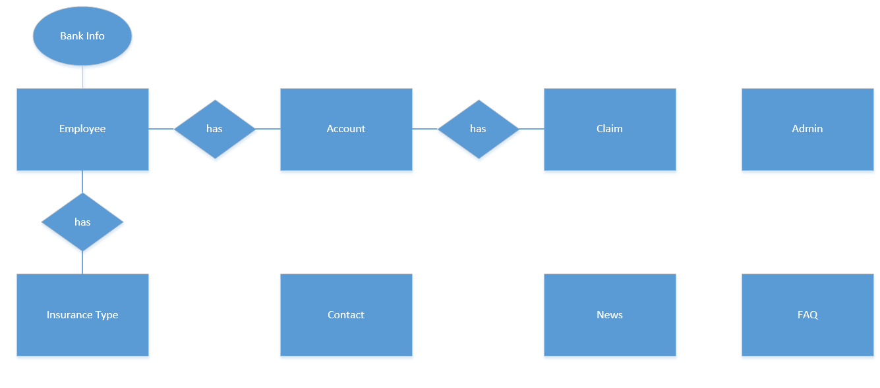

# Logical



# Tables

# Admin



# Employee



# BankInfo



# Account



# Insurance



# InsuranceType



# Claim



# FAQ



# News

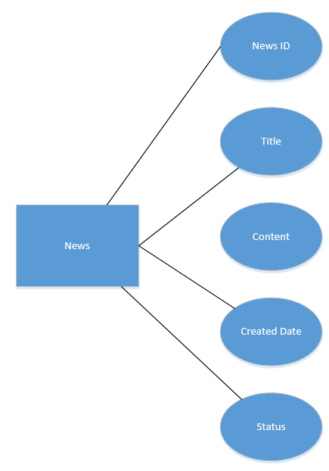

# Contact

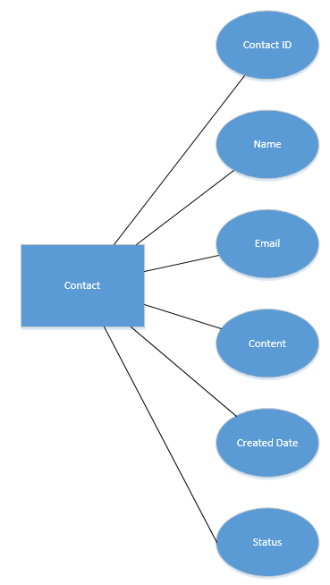

|  |  |  |
| --- | --- | --- |
|  | **Prepared by (Student)** | **Approved by (Faculty)** |
| **Signature** | Team leader  **Dang Tran Ngoc Phuong** | **Ngo Phuoc Nguyen** |
| **Date** |  |  |

REVIEW 3

# 

# Database Relationship Diagram



# 

# Table Definition

# *Admin*

|  |  |  |  |  |  |  |  |
| --- | --- | --- | --- | --- | --- | --- | --- |
| **Key** | **Field Name** | **Data Type** | **Length** | **Allow Null** | **Default value** | **Field-Ref** | **Description** |
| PK | **Username** | nvarchar | 30 | No |  |  | Username |
|  | Password | nvarchar | 30 | No |  |  | Password |

### Constraint:

* UNIQUE: username must be unique

|  |  |  |  |
| --- | --- | --- | --- |
| **Name** | **Add** | **Delete** | **Update** |
| Username | +  (username) | - | +  (username) |

# *Employee*

|  |  |  |  |  |  |  |  |
| --- | --- | --- | --- | --- | --- | --- | --- |
| **Key** | **Field Name** | **Data Type** | **Length** | **Allow Null** | **Default value** | **Field-Ref** | **Description** |
| PK | **EmployeeID** | nvarchar | 6 | No |  |  |  |
|  | FirstName | nvarchar | 20 | No |  |  |  |
|  | MiddleName | nvarchar | 20 | Yes |  |  |  |
|  | LastName | nvarchar | 20 | No |  |  |  |
|  | DateOfBirth | datetime | 8 | No |  |  |  |
|  | IDNumber | nvarchar | 10 | No |  |  |  |
|  | AccountCode | nvarchar | 10 | No |  |  |  |
|  | BankID | int | 200 | No |  |  |  |
|  | AccountNumber | nvarchar | 16 | No |  |  |  |
|  | Status | Bit | 1 | No | 1 |  | 1: active  0: inactive |

### Constraint:

* UNIQUE: IDNumber must be unique
* UNIQUE: AccountCode must be unique
* UNIQUE: AccountNumber must be unique
* FOREIGN KEY: BankID must exist

|  |  |  |  |
| --- | --- | --- | --- |
| **Name** | **Add** | **Delete** | **Update** |
| Employee | +  (IDNumber, AccountCode, AccountNumber)  BankInfo.BankID must exist | - | +  (IDNumber, AccountCode, AccountNumber)  BankInfo.BankID must exist |

# *Account*

|  |  |  |  |  |  |  |  |
| --- | --- | --- | --- | --- | --- | --- | --- |
| **Key** | **Field Name** | **Data Type** | **Length** | **Allow Null** | **Default value** | **Field-Ref** | **Description** |
| PK | **AccountID** | int | 4 | No | IDENTITY(1,1) |  |  |
|  | Username | nvarchar | 50 | No |  |  |  |
|  | Password | nvarchar | 50 | No |  |  |  |
|  | EmployeeID | nvarchar | 6 | No |  | Employee.EmployeeID |  |
|  | Email | nvarchar | 50 | No |  |  |  |
|  | FirstAddress | nvarchar | 50 | No |  |  |  |
|  | SecondAddress | nvarchar | 50 | Yes |  |  |  |
|  | PhoneNumber | nvarchar | 10 | No |  |  |  |
|  | Image | nvarchar | 50 | Yes |  |  |  |
|  | Status | bit | 1 | No | 1 |  | 1: active  0: inactive |

### Constraint:

* UNIQUE: Username must be unique
* UNIQUE: Email must be unique
* UNIQUE: PhoneNumber must be unique
* FOREIGN KEY: EmployeeID must exist

|  |  |  |  |
| --- | --- | --- | --- |
| **Name** | **Add** | **Delete** | **Update** |
| Account | +  (Username, Email, PhoneNumber)  Employee.EmployeeID must exist | - | +  (Username, Email, PhoneNumber)  Employee.EmployeeID must exist |

# *Claim*

|  |  |  |  |  |  |  |  |
| --- | --- | --- | --- | --- | --- | --- | --- |
| **Key** | **Field Name** | **Data Type** | **Length** | **Allow Null** | **Default value** | **Field-Ref** | **Description** |
| PK | **ClaimID** | Int | 4 | No | IDENTITY (1,1) |  |  |
| FK | AccountID | Int | 4 | No |  | Account.AccountID |  |
| FK | InsuranceID | Int | 4 | No |  | Insurance.InsuranceID |  |
|  | ClaimAmount | Float | 8 | No |  |  |  |
|  | ClaimDate | Datetime | 8 | No | Current date |  |  |
|  | ClaimReason | Nvarchar | 400 | No |  |  |  |
|  | Attachment | Nvarchar | 250 | No |  |  |  |
|  | HospitalName | Nvarchar | 50 | No |  |  |  |
|  | HospitalAddress | Nvarchar | 50 | No |  |  |  |
|  | HospitalPhone | Nvarchar | 50 | No |  |  |  |
|  | HospitalFax | Nvarchar | 50 | Yes |  |  |  |
|  | HospitalEmail | Nvarchar | 50 | Yes |  |  |  |
|  | ClaimStatus | Nvarchar | 10 | No | Processed |  |  |
|  | Status | Bit | 1 | No | 1 |  | 1: active  0: inactive |

### Constraint:

* FOREIGN KEY: AccountID must exist
* FOREIGN KEY: InsuranceID must exist

|  |  |  |  |
| --- | --- | --- | --- |
| **Name** | **Add** | **Delete** | **Update** |
| Claim | +  Account.AccountID and Insurance.InsuranceID must exist | - | +  Account.AccountID and Insurance.InsuranceID must exist |

# *InsuranceType*

|  |  |  |  |  |  |  |  |
| --- | --- | --- | --- | --- | --- | --- | --- |
| **Key** | **Field Name** | **Data Type** | **Length** | **Allow Null** | **Default value** | **Field-Ref** | **Description** |
| PK | **InsuranceTypeID** | Int | 4 | No |  |  |  |
|  | Name | nvarchar | 50 | No |  |  |  |
|  | Description | nvarchar | 400 | No |  |  |  |
|  | MaximumReimbursement | float | 8 | No |  |  |  |

### Constraint:

* UNIQUE: Name must be unique

|  |  |  |  |
| --- | --- | --- | --- |
| **Name** | **Add** | **Delete** | **Update** |
| InsuranceType | +  (Name) | - | +  (Name) |

# *Insurance*

|  |  |  |  |  |  |  |  |
| --- | --- | --- | --- | --- | --- | --- | --- |
| **Key** | **Field Name** | **Data Type** | **Length** | **Allow Null** | **Default value** | **Field-Ref** | **Description** |
| PK | **InsuranceID** | Int | 4 | No | IDENTITY(1,1) |  |  |
| FK | EmployeeID | nvarchar | 4 | No |  | Employee.EmployeeID |  |
| FK | InsuranceTypeID | Int | 4 | No |  | InsuranceType.InsuranceTypeID |  |
|  | PolicyNumber | Int | 4 | No |  |  |  |
|  | CreatedDate | datetime | 8 | No |  |  |  |
|  | ExpiredDate | datetime | 8 | No |  |  |  |
|  | Status | Bit | 1 | No | 1 |  | 1: active  0: inactive |

### Constraint:

* UNIQUE: PolicyNumber must be unique
* FOREIGN KEY: EmployeeID must exist
* FOREIGN KEY: InsuranceTypeID must exist

|  |  |  |  |
| --- | --- | --- | --- |
| **Name** | **Add** | **Delete** | **Update** |
| Insurance | +  (PolicyNumber)  Employee.EmployeeID and InsuranceType.InsuranceTypeID must exist | - | +  (PolicyNumber)  Employee.EmployeeID and InsuranceType.InsuranceTypeID must exist |

# *BankInfo*

|  |  |  |  |  |  |  |  |
| --- | --- | --- | --- | --- | --- | --- | --- |
| **Key** | **Field Name** | **Data Type** | **Length** | **Allow Null** | **Default value** | **Field-Ref** | **Description** |
| PK | **BankID** | int | 4 | No | IDENTITY(1,1) |  |  |
|  | BankName | nvarchar | 50 | No |  |  |  |
|  | BankAddress | nvarchar | 50 | No |  |  |  |

### Contrainst:

* UNIQUE: BankName must be unique

|  |  |  |  |
| --- | --- | --- | --- |
| **Name** | **Add** | **Delete** | **Update** |
| BankInfo | +  (BankName) | - | +  (BankName) |

# *Contact*

|  |  |  |  |  |  |  |  |
| --- | --- | --- | --- | --- | --- | --- | --- |
| **Key** | **Field Name** | **Data Type** | **Length** | **Allow Null** | **Default value** | **Field-Ref** | **Description** |
| PK | **ContactID** | int | 4 | No |  |  |  |
|  | Title | nvarchar | 50 | No |  |  |  |
|  | Name | nvarchar | 50 | No |  |  |  |
|  | Email | nvarchar | 50 | No |  |  |  |
|  | Content | nvarchar | 400 | No |  |  |  |
|  | CreatedDate | datetime | 8 | No | Current date |  |  |
|  | Status | bit | 1 | No | 1 |  | 1: active  0: inactive |

### Contrainst:

* UNIQUE: Title must be unique

|  |  |  |  |
| --- | --- | --- | --- |
| **Name** | **Add** | **Delete** | **Update** |
| Contact | +  (Title) | - | +  (Title) |

# *News*

|  |  |  |  |  |  |  |  |
| --- | --- | --- | --- | --- | --- | --- | --- |
| **Key** | **Field Name** | **Data Type** | **Length** | **Allow Null** | **Default value** | **Field-Ref** | **Description** |
| PK | **NewsID** | int | 4 | No |  |  |  |
|  | Title | nvarchar | 50 | No |  |  |  |
|  | Content | nvarchar | 4000 | No |  |  |  |
|  | CretaedDate | Datetime | 8 | No |  |  |  |
|  | Status | bit | 1 | No | 1 |  | 1: active  0: inactive |

### Contrainst:

* UNIQUE: Title must be unique

|  |  |  |  |
| --- | --- | --- | --- |
| **Name** | **Add** | **Delete** | **Update** |
| News | +  (Title) | - | +  (Title) |

# *FAQ*

|  |  |  |  |  |  |  |  |
| --- | --- | --- | --- | --- | --- | --- | --- |
| **Key** | **Field Name** | **Data Type** | **Length** | **Allow Null** | **Default value** | **Field-Ref** | **Description** |
| PK | **FAQID** | nvarchar | 4 | No |  |  | FAQ ID  Identity |
|  | Question | nvarchar | 400 | No |  |  | Question |
|  | Answer | nvarchar | 400 | No |  |  | Answer |
|  | Status | bit | 1 | No | 1 |  | 1: active  0: inactive |

### Contrainst:

* UNIQUE: Question must be unique

|  |  |  |  |
| --- | --- | --- | --- |
| **Name** | **Add** | **Delete** | **Update** |
| FAQ | +  (Question) | - | +  (Question) |

**3. GUI Design**

**3.1 Home side**

**3.1.1 Admin Login Page**

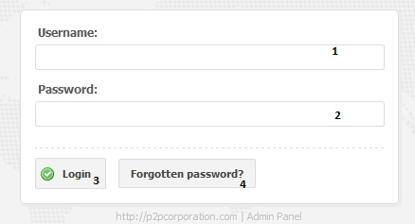

|  |  |  |  |  |  |  |
| --- | --- | --- | --- | --- | --- | --- |
| **No.** | **Name** | **Type** | **Validation** | **Event** | **Description** | **Status** |
| 1 | txtUsername | Text field | Not null |  | Username |  |
| 2 | txtPassword | Text field | Not null |  | Password |  |
| 3 | btnLogin | Button |  | Click | Check Username and password and if they are correct, redirect to Admin Home page |  |
| 4 | btnForgotten | Button |  | Click | Retrieved password |  |

**3.1.2 Admin Page**

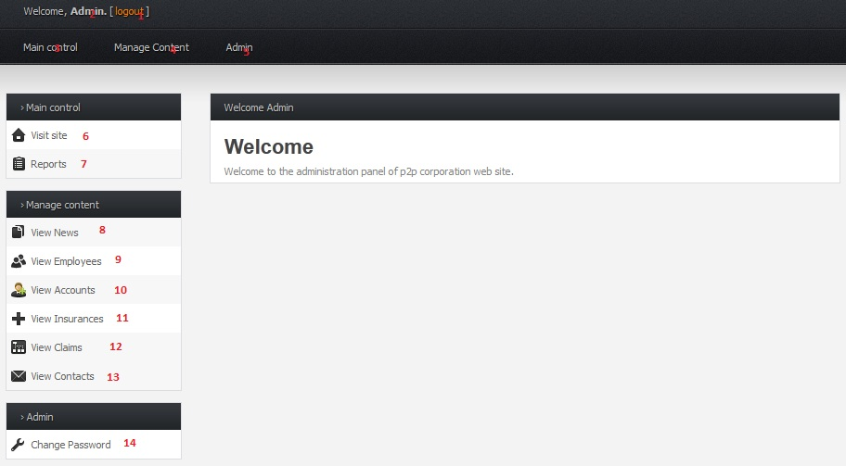

|  |  |  |  |  |  |  |
| --- | --- | --- | --- | --- | --- | --- |
| **No.** | **Name** | **Type** | **Validation** | **Event** | **Description** | **Status** |
| 1 | btnLogout | Button |  | Click | Logout current account |  |
| 2 | lblAdmin | Label |  |  | Current Username |  |
| 3 | btnMaincontrol | Button |  | Click | Main Control |  |
| 4 | btnManageContent | Button |  | Click | Mange Content |  |
| 5 | btnAdmin | Button |  | Click | Admin’s mastery |  |
| 6 | btnVisitSite | Hyperlink |  | Click | Redirect to Homepage |  |
| 7 | btnReports | Hyperlink |  | Click | Redirect to Reports page |  |
| 8 | btnViewnews | Hyperlink |  | Click | Redirect to ViewNews page |  |
| 9 | btnViewEmployees | Hyperlink |  | Click | Redirect to ViewEmployee page |  |
| 10 | btnViewAccounts | Hyperlink |  | Click | Redirect to ViewAccounts page |  |
| 11 | btnViewInsurances | Hyperlink |  | Click | Redirect to ViewInsurances page |  |
| 12 | btnViewClaims | Hyperlink |  | Click | Redirect to ViewClaims page |  |
| 13 | btnViewContacts | Hyperlink |  | Click | Redirect to ViewContacts page |  |
| 14 | btnChangePassword | Hyperlink |  | Click | Redirect to ChangePassword page |  |

**3.1.3 Admin Change Password**

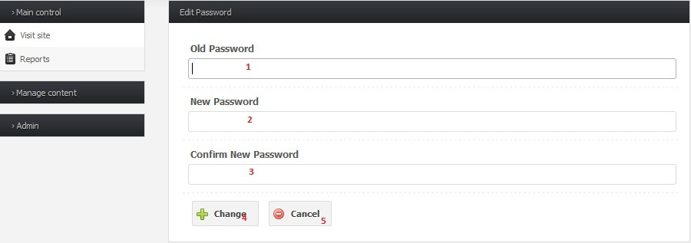

|  |  |  |  |  |  |  |
| --- | --- | --- | --- | --- | --- | --- |
| **No.** | **Name** | **Type** | **Validation** | **Event** | **Description** | **Status** |
| 1 | txtOldpassword | Password | 0<length<=50 |  | Old Password |  |
| 2 | txtNewpassword | Password | 0<length<=50 |  | New Password |  |
| 3 | txtConfirmpassword | Password | 0<length<=50 |  | Confirm Password |  |
| 4 | btnChange | Button |  | Click | Submit New Password |  |
| 5 | btnCancel | Button |  | Click | Redirect to Login page |  |

**3.1.4 Views Accounts Page**

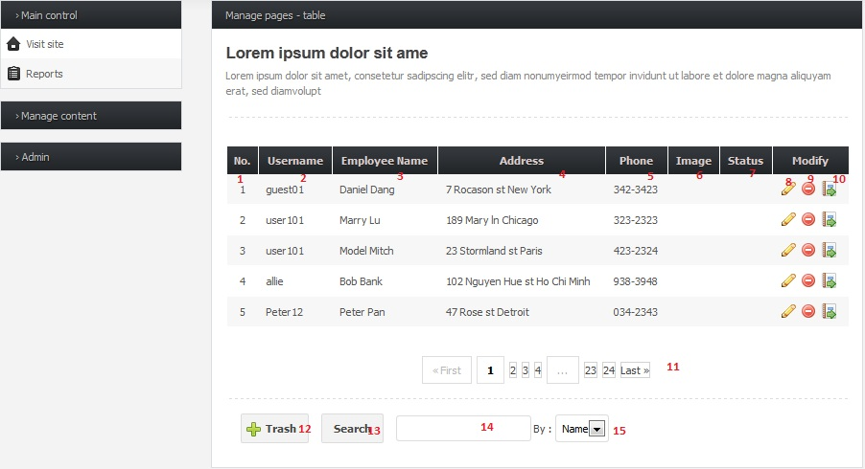

|  |  |  |  |  |  |  |
| --- | --- | --- | --- | --- | --- | --- |
| **No.** | **Name** | **Type** | **Validation** | **Event** | **Description** | **Status** |
| 1 | lblNo | Label |  |  | Ordinal number |  |
| 2 | lblUser | Label |  |  | User name Account |  |
| 3 | lblName | Label |  |  | Employee’s Name |  |
| 4 | lblAddress | Label |  |  | Account’s Address |  |
| 5 | lblPhone | Label |  |  | Account’s Phone number |  |
| 6 | Image | Image |  |  | Image Account |  |
| 7 | imgStatus | Image |  |  | Image of status |  |
| 8 | btnEdit | Button |  | Click | Edit information |  |
| 9 | btnDelete | Button |  | Click | Delete a account |  |
| 10 | btnArchive | Button |  | Click | Archive account |  |
| 11 | Paging | Paging |  | Click | Go to page |  |
| 12 | btnTrash | Button |  | Click | Show all records deleted |  |
| 13 | btnSearch | Button |  | Click | Show search result |  |
| 14 | txtSearch | Text field |  |  | Input information to search |  |
| 18 | cbbAccount | Combo Box |  | Click | Search Account: Username |  |

**3.1.5 View Claims**

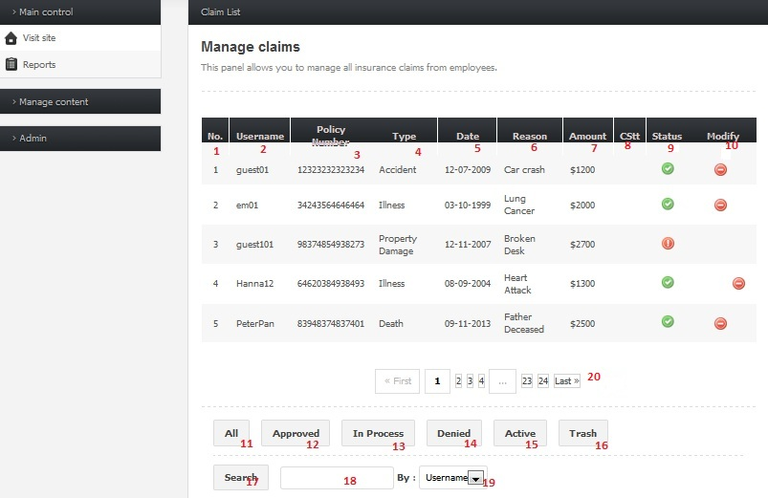

|  |  |  |  |  |  |  |
| --- | --- | --- | --- | --- | --- | --- |
| **No.** | **Name** | **Type** | **Validation** | **Event** | **Description** | **Status** |
| 1 | lblNo | Label |  |  | Ordinal number |  |
| 2 | lblUser | Label |  |  | Username Account |  |
| 3 | lblPolicyNumber | Label |  |  | Policy Number |  |
| 4 | lblType | Label |  |  | Type Claim |  |
| 5 | lblIDate | Label |  |  | Date of Claim |  |
| 6 | lblReason | Label |  |  | Claim Reason |  |
| 7 | lblAmount | Label |  |  | Claim Amount |  |
| 8 | imgCStt | Image |  |  | Image of Claim status |  |
| 9 | imgStatus | Image |  |  | Image of status |  |
| 10 | btnDelete | Button |  | Click | Delete a claim |  |
| 11 | btnAll | Button |  | Click | Show all status of record |  |
| 12 | btnApproved | Button |  | Click | Approved Claim |  |
| 13 | btnInprocess | Button |  | Click | Claim in process solved |  |
| 14 | btnDenied | Button |  | Click | Denied Claim |  |
| 15 | btnActive | Button |  | Click | Show status of records still Active |  |
| 16 | btnTrash | Button |  | Click | Show all records deleted |  |
| 17 | btnSearch | Button |  | Click | Show search result |  |
| 18 | txtSearch | Text field |  |  | Input information to search |  |
| 19 | cbbClaim | Combo Box |  | Click | Search Claim:Username |  |

3.1.6 ViewEmployee page

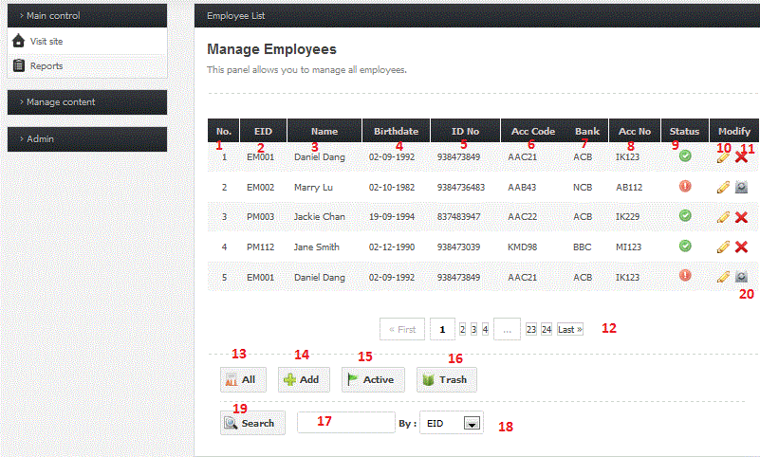

|  |  |  |  |  |  |  |
| --- | --- | --- | --- | --- | --- | --- |
| **No.** | **Name** | **Type** | **Validation** | **Event** | **Description** | **Status** |
| 1 | lblNo | Label |  |  | Ordinal number |  |
| 2 | lblEID | Label |  |  | Employee ID |  |
| 3 | lblName | Label |  |  | Employee’s Name |  |
| 4 | lblBirthdate | Label |  |  | Employee’s Birthdate |  |
| 5 | lblIDNo | Label |  |  | Employee’s ID number |  |
| 6 | lblAccCode | Label |  |  | Employee’s Account Code |  |
| 7 | lblBank | Label |  |  | Bank’name |  |
| 8 | lblAccNo | Label |  |  | Bank account number |  |
| 9 | imgStatus | Image |  |  | Image of status |  |
| 10 | btnEdit | Button |  | Click | Edit information |  |
| 11 | btnDelete | Button |  | Click | Delete a employee account |  |
| 12 | Paging | Paging |  | Click | Go to page |  |
| 13 | btnAll | Button |  | Click | Show all status of record |  |
| 14 | btnAdd | Button |  | Click | Add a Employee’s account |  |
| 15 | btnActive | Button |  | Click | Show status of records still Active |  |
| 16 | btnTrash | Button |  | Click | Show all records deleted |  |
| 17 | txtSearch | Text field |  |  | Input information to search |  |
| 18 | cbbEmployee | Combo Box |  | Click | Search Employee: EID, name, ID No, Acc code, bank’s name, bank account |  |
| 19 | btnSearch | Button |  | Click | Show search result |  |
| 20 | btnRestore | Button |  | Click | Restore Employee record deleted |  |

3.1.7 View Faqs page

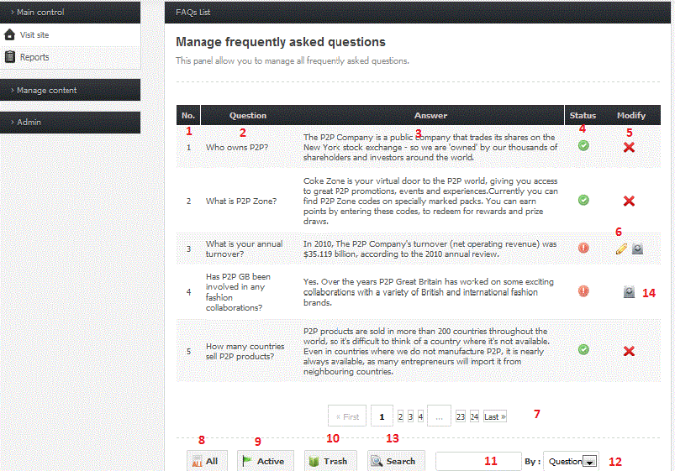

|  |  |  |  |  |  |  |
| --- | --- | --- | --- | --- | --- | --- |
| **No.** | **Name** | **Type** | **Validation** | **Event** | **Description** | **Status** |
| 1 | lblNo | Label |  |  | Ordinal number |  |
| 2 | lblQuestion | Label |  |  | Question |  |
| 3 | lblAnswer | Label |  |  | Answer |  |
| 4 | imgStatus | Image |  |  | Image of status |  |
| 5 | btnDelete | Button |  |  | Delete a FAQ |  |
| 6 | btnEdit | Button |  |  | Edit a FAQ |  |
| 7 | Paging | Paging |  |  | Go to page |  |
| 8 | btnAll | Button |  | Click | Show all status of FAQ |  |
| 9 | btnActive | Button |  | Click | Show status of FAQ still Active |  |
| 10 | btnTrash | Button |  | Click | Show all FAQs deleted |  |
| 11 | txtSearch | Text field |  |  | Input information to search |  |
| 12 | cbbFAQ | Combo Box |  | Click | Search FAQs: question, answer |  |
| 13 | btnSearch | Button |  | Click | Show search result |  |
| 14 | btnRestore | Button |  | Click | Restore FAQ deleted |  |

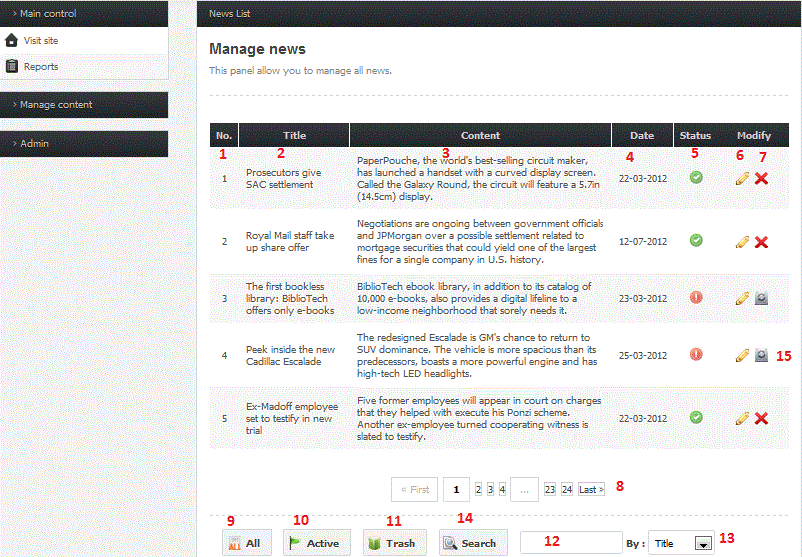

|  |  |  |  |  |  |  |
| --- | --- | --- | --- | --- | --- | --- |
| **No.** | **Name** | **Type** | **Validation** | **Event** | **Description** | **Status** |
| 1 | lblNo | Label |  |  | Ordinal number |  |
| 2 | lblTitle | Label |  |  | Title of news |  |
| 3 | lblContent | Label |  |  | Content of news |  |
| 4 | lblDate | Label |  |  | Date of news |  |
| 5 | imgStatus | Image |  |  | Image of Status |  |
| 6 | btnEdit | Button |  | Click | Edit a News |  |
| 7 | btnDelete | Button |  | Click | Delete a News |  |
| 8 | Paging | Paging |  |  | Go to page |  |
| 9 | btnAll | Button |  | Click | Show all status of News |  |
| 10 | btnActive | Button |  | Click | Show status of News still Active |  |
| 11 | btnTrash | Button |  | Click | Show all News deleted |  |
| 12 | txtSearch | Text field |  |  | Input information to search |  |
| 13 | cbbNews | Combo Box |  | Click | Search News: title, content, date |  |
| 14 | btnSearch | Button |  | Click | Show search result |  |
| 15 | btnRestore | Button |  | Click | Restore news deleted |  |

3.1.8 View Insurance Types page

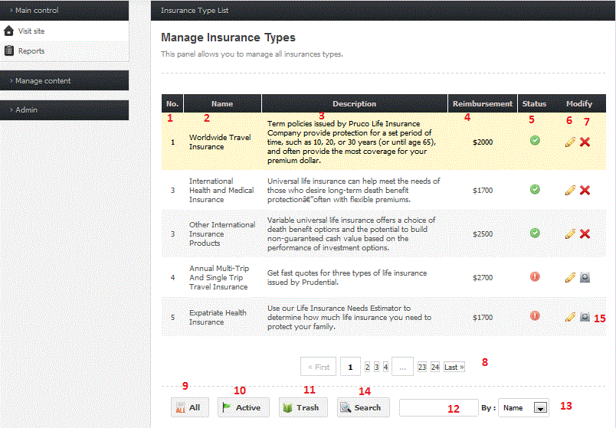

|  |  |  |  |  |  |  |
| --- | --- | --- | --- | --- | --- | --- |
| **No.** | **Name** | **Type** | **Validation** | **Event** | **Description** | **Status** |
| 1 | lblNo | Label |  |  | Ordinal number |  |
| 2 | lblName | Label |  |  | Name of Insurance type |  |
| 3 | lblDescription | Label |  |  | Description about this Insurance type |  |
| 4 | lblReimbursement | Label |  |  | Reimbursement of Insurance |  |
| 5 | imgStatus | Image |  |  | Image of Status |  |
| 6 | btnEdit | Button |  | Click | Edit an Insurance Type |  |
| 7 | btnDelete | Button |  | Click | Delete an Insurance Type |  |
| 8 | Paging | Paging |  |  | Go to page |  |
| 9 | btnAll | Button |  | Click | Show all status of Insurance Type |  |
| 10 | btnActive | Button |  | Click | Show status of Insurance Type still Active |  |
| 11 | btnTrash | Button |  | Click | Show all Insurance Type deleted |  |
| 12 | txtSearch | Text field |  |  | Input information to search |  |
| 13 | cbbInsuranceType | Combo Box |  | Click | Search Insurance Type: title, content, date |  |
| 14 | btnSearch | Button |  | Click | Show search result |  |
| 15 | btnRestore | Button |  | Click | Restore Insurance Type deleted |  |

3.1.9 **View Contact page**

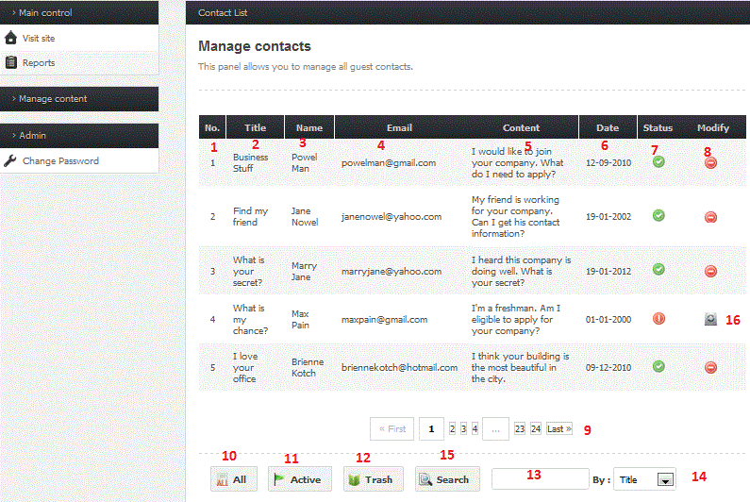

|  |  |  |  |  |  |  |
| --- | --- | --- | --- | --- | --- | --- |
| **No.** | **Name** | **Type** | **Validation** | **Event** | **Description** | **Status** |
| 1 | lblNo | Label |  |  | Ordinal number |  |
| 2 | lblTitle | Label |  |  | Title of Contact |  |
| 3 | lblName | Label |  |  | Sender’s name |  |
| 4 | lblEmail | Label |  |  | Sender’s email |  |
| 5 | lblContent | Label |  |  | Content of Contact |  |
| 6 | lblDate | Label |  |  | Date of contact |  |
| 7 | imgStatus | Image |  |  | Image of Status |  |
| 8 | btnDelete | Button |  | Click | Delete an Insurance Type |  |
| 9 | Paging | Paging |  |  | Go to page |  |
| 10 | btnAll | Button |  | Click | Show all status of Contact |  |
| 11 | btnActive | Button |  | Click | Show status of Contact still Active |  |
| 12 | btnTrash | Button |  | Click | Show all Contact deleted |  |
| 13 | txtSearch | Text field |  |  | Input information to search |  |
| 14 | cbbContact | Combo Box |  | Click | Search Contact: title, content, date |  |
| 15 | btnSearch | Button |  | Click | Show search result |  |
| 16 | btnRestore | Button |  | Click | Restore contacts deleted |  |

**3.2 Guest side**

**3.2.1 Insurance page**

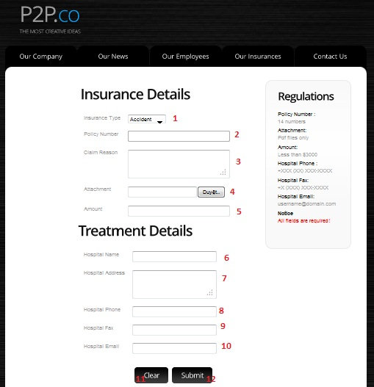

|  |  |  |  |  |  |  |
| --- | --- | --- | --- | --- | --- | --- |
| **No.** | **Name** | **Type** | **Validation** | **Event** | **Description** | **Status** |
| 1 | cbbinsuranceType | Combobox |  | Click | Data get from InsuranceType table |  |
| 2 | txtpolicyNumber | Textfield | 0<length<=14 |  | Policy Number |  |
| 3 | txtclaimReason | Textfield | 0<length<=400 |  | Claim Reason |  |
| 4 | attachment | File field |  | Click | Attachment file |  |
| 5 | txtamount | Textfield |  |  | Amount Claim |  |
| 6 | txthospitalName | Textfield | 0<length<=50 |  | Hospital Name |  |
| 7 | txthospitalAddress | Textfield | 0<length<=50 |  | Hospital Address |  |
| 8 | txthospitalPhone | Int box | 8<=length<=14  [0-9], allow) |  | Hospital Phone |  |
| 9 | txthospitalFax | Textfield | 0<length<=50 |  | Hospital Fax |  |
| 10 | txthospitalEmail | Textfield | /.+@.+\.[a-z]+/ |  | Hospital Email |  |
| 11 | btnClear | Button |  | Click | Clear all field Claim |  |
| 12 | btnSubmit | Button |  | Click | Submit Claim Insurance |  |

**3.2.2 Contact Page**

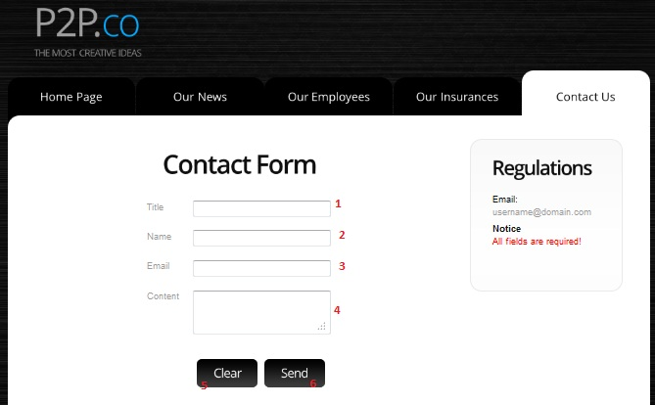

|  |  |  |  |  |  |  |
| --- | --- | --- | --- | --- | --- | --- |
| **No.** | **Name** | **Type** | **Validation** | **Event** | **Description** | **Status** |
| 1 | txttitle | Textfield | 0<length<=50 |  | Contact title |  |
| 2 | txtname | Textfield | 0<length<=50 |  | Contact name |  |
| 3 | txtemail | Textfield | 0<length<=50 |  | Contact email |  |
| 4 | txtcontent | Textfield | 0<length<=400 |  | Contact content |  |
| 5 | btnclear | Button |  | Click | Clear all field contact |  |
| 6 | btnsend | button |  | Click | Send contact |  |

**3.2.3 Employee Page**

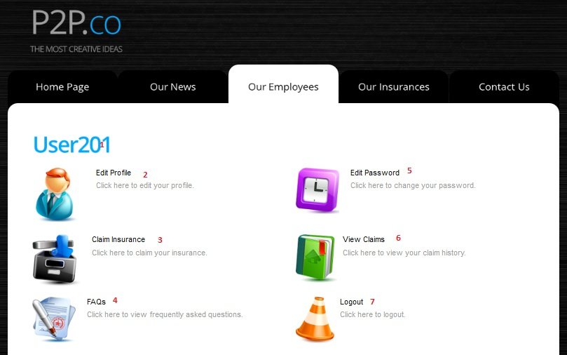

|  |  |  |  |  |  |  |
| --- | --- | --- | --- | --- | --- | --- |
| **No.** | **Name** | **Type** | **Validation** | **Event** | **Description** | **Status** |
| 1 | lblUser | Label |  |  | Employee ID |  |
| 2 | btneditprofile | Hyperlink |  | Click | Redirect to EditUserProfile page |  |
| 3 | btnclaimInsurance | Hyperlink |  | Click | Redirect to Claim Insurance page |  |
| 4 | btnfaqs | Hyperlink |  | Click | Redirect to Faqs page |  |
| 5 | btneditPassword | Hyperlink |  | Click | Redirect to ChangePassword page |  |
| 6 | btnviewClaims | Hyperlink |  | Click | Redirect to ViewClaims page |  |
| 7 | btnLogout | Hyperlink |  | Click | Redirect to List of Logout current account page |  |

**3.2.4 FAQS Page**

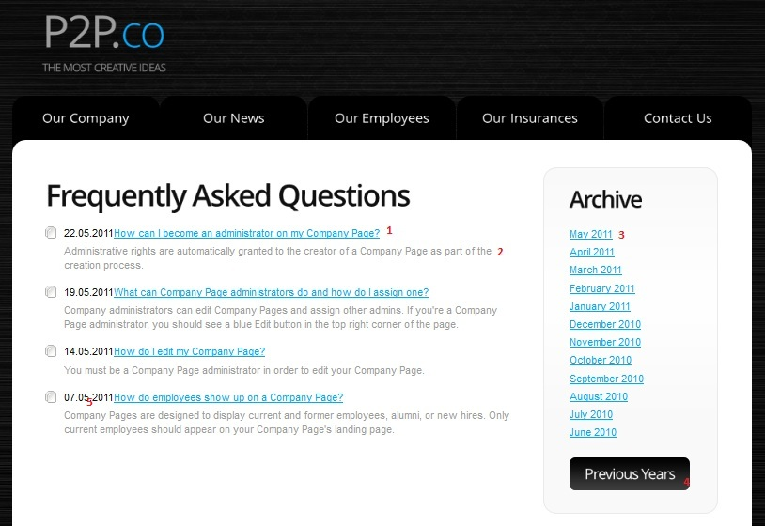

|  |  |  |  |  |  |  |
| --- | --- | --- | --- | --- | --- | --- |
| **No.** | **Name** | **Type** | **Validation** | **Event** | **Description** | **Status** |
| 1 | linkQuestions | Hyperlink |  | Click | FAQ Question |  |
| 2 | lblAnswer | Label |  |  | FAQ Answer |  |
| 3 | linkDate | Hyperlink |  | Click | Search news of this year and show result on FAQs page |  |
| 4 | btnPrevious Years | Button |  | Click | Previous year |  |
| 5 | lblDate | Label |  |  | Date of questions |  |

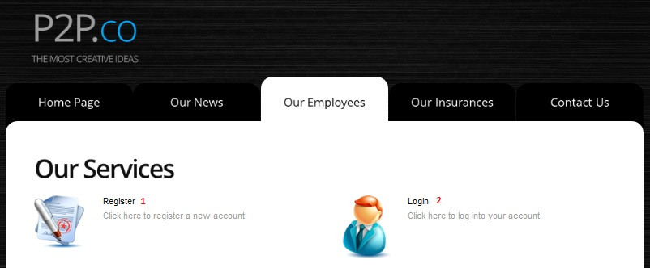

|  |  |  |  |  |  |  |
| --- | --- | --- | --- | --- | --- | --- |
| **No.** | **Name** | **Type** | **Validation** | **Event** | **Description** | **Status** |
| 1 | register | Hyperlink |  | Click | Redirect to Register page |  |
| 2 | login | Hyperlink |  | Click | Redirect to Login page |  |

**3.2.5 About Us Page**



|  |  |  |  |  |  |  |
| --- | --- | --- | --- | --- | --- | --- |
| **No.** | **Name** | **Type** | **Validation** | **Event** | **Description** | **Status** |
| 1 | lblaboutUs | Label |  |  | Description about Company |  |

**3.2.6 Home Page**



|  |  |  |  |  |  |  |
| --- | --- | --- | --- | --- | --- | --- |
| **No.** | **Name** | **Type** | **Validation** | **Event** | **Description** | **Status** |
| 1 | btnhome | Button |  | Click | Redirect to Home page |  |
| 2 | btnnews | Button |  | Click | Redirect to News page |  |
| 3 | btnemployees | Button |  | Click | Redirect to Employees page |  |
| 4 | btnInsurance | Button |  | Click | Redirect to Insurance page |  |
| 5 | btncontactus | Button |  | Click | Redirect to Contact page |  |
| 6 | Img | Image |  |  | Preview images introduced |  |

**3.2.7 ChangePassword page**

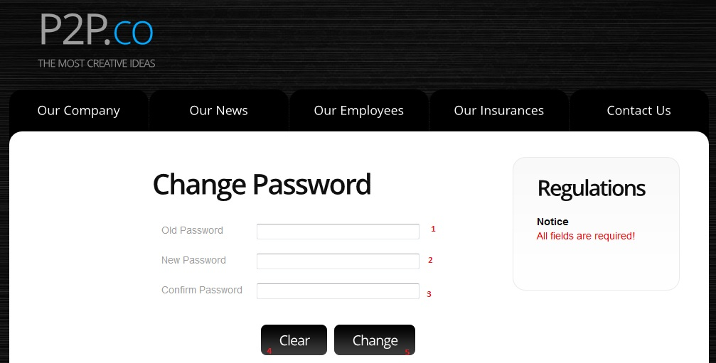

|  |  |  |  |  |  |  |
| --- | --- | --- | --- | --- | --- | --- |
| **No.** | **Name** | **Type** | **Validation** | **Event** | **Description** | **Status** |
| 1 | txtOldpassword | Password | 0<length<=50 |  | Old Password |  |
| 2 | txtNewpassword | Password | 0<length<=50 |  | New Password |  |
| 3 | txtConfirmpassword | Password | 0<length<=50 |  | Confirm Password |  |
| 4 | btnClear | Button |  | Click | Clear all field password |  |
| 5 | btnChange | Button |  | Click | Submit New Password |  |

**3.2.8 Edit User Profile Page**

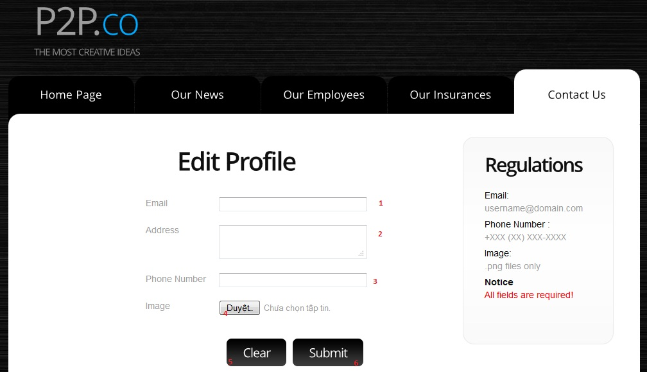

|  |  |  |  |  |  |  |
| --- | --- | --- | --- | --- | --- | --- |
| **No.** | **Name** | **Type** | **Validation** | **Event** | **Description** | **Status** |
| 1 | txtEmail | TextField | Not null |  | Employee’s email |  |
| 2 | txtAddress | Password | Not null |  | Employee’s address |  |
| 3 | txtPhoneNumber | Password | 8<=length<=14  [0-9], allow |  | Employee’s Phone number |  |
| 4 | imgBrower | File field | Not null |  | Brower picture for employee |  |
| 5 | btnClear | Button |  | Click | Clear all field editprofile |  |
| 6 | btnChange | Button |  | Click | Submit edit profile |  |

**3.2.9 Insurance List page**



|  |  |  |  |  |  |  |
| --- | --- | --- | --- | --- | --- | --- |
| **No.** | **Name** | **Type** | **Validation** | **Event** | **Description** | **Status** |
| 1 | InsuranceType | HyperLink |  | Click | Redirect to list of Insurance page |  |
| 2 | imgInsurance | Image |  |  | Image of Insurance |  |
| 3 | lblInsurance | label |  |  | Description about this insurance type |  |

**3.2.10 Insurance Details page**



|  |  |  |  |  |  |  |
| --- | --- | --- | --- | --- | --- | --- |
| **No.** | **Name** | **Type** | **Validation** | **Event** | **Description** | **Status** |
| 1 | lblInsuranceDetail | Label |  |  | Description about Insurance |  |
| 2 | InsuranceList | HyperLink |  | Click | Redirect to list of Insurance page |  |

**3.2.11 Register page**

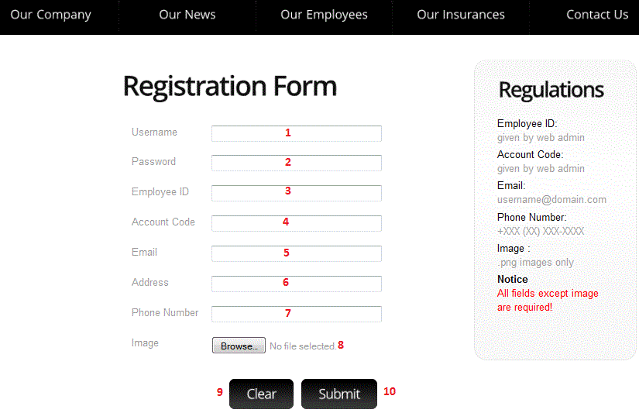

|  |  |  |  |  |  |  |
| --- | --- | --- | --- | --- | --- | --- |
| **No.** | **Name** | **Type** | **Validation** | **Event** | **Description** | **Status** |
| 1 | txtUsername | Text field | Max length 30 characters |  | Employee’s Username |  |
| 2 | txtPassword | Text field | Max length 30 characters |  | Employee’s password |  |
| 3 | txtEmployeeID | Text field | Max length 30 characters |  | Employee ID |  |
| 4 | txtAccountCode | Text field | Max length 10 characters |  | Employee’s Account Code |  |
| 5 | txtEmail | Text field | Not null |  | Employee’s email |  |
| 6 | txtAddress | Text field | Not null |  | Employee’s address |  |
| 7 | txtPhoneNumber | Text field | 8<=length<=14  [0-9], allow null |  | Employee’s Phone number |  |
| 8 | imgBrower | File field | Not null | Click | Brower picture for employee |  |
| 9 | btnclear | Button |  | Click | Clear all field register |  |
| 10 | btnSubmit | Button |  | Click | Submit register and redirect to Login page |  |

**3.2.12 Login page**

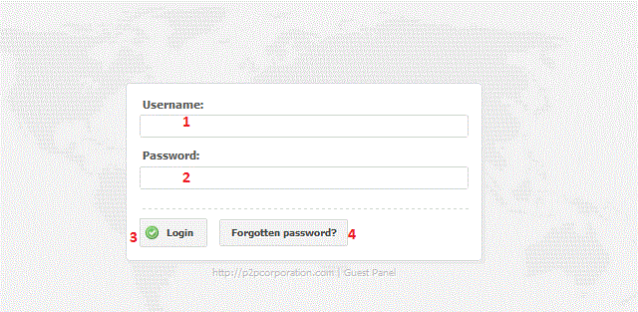

|  |  |  |  |  |  |  |
| --- | --- | --- | --- | --- | --- | --- |
| **No.** | **Name** | **Type** | **Validation** | **Event** | **Description** | **Status** |
| 1 | txtUsername | Text field | Not null |  | Input Username |  |
| 2 | txtPassword | Text field | Not null |  | Input Password |  |
| 3 | btnLogin | Button |  | Click | Login to the system and redirect to EmployeeMenu page |  |
| 4 | btnForgottenpassword | Button |  | Click | Redirect to retrieve password page |  |

**3.2.13 NewsList page**

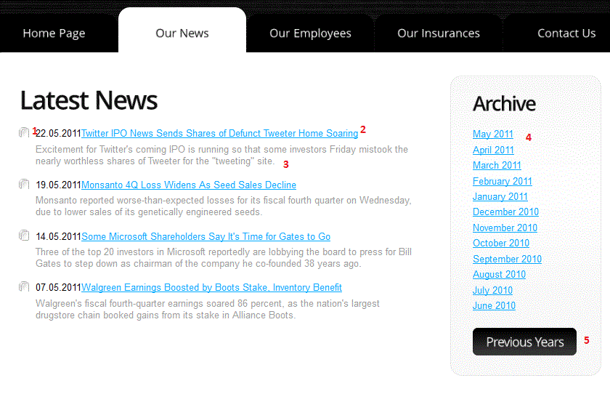

|  |  |  |  |  |  |  |
| --- | --- | --- | --- | --- | --- | --- |
| **No.** | **Name** | **Type** | **Validation** | **Event** | **Description** | **Status** |
| 1 | lblDate | Label |  |  | Date of news |  |
| 2 | linkNews | HyperLink |  | Click | Redirect to newsContent page |  |
| 3 | lblShortContent | Label |  |  | Short content of news |  |
| 4 | linkDate | HyperLink |  | Click | Search news of this year and show result on newsList page |  |
| 5 | btnPrevious Years | Button |  | Click | Previous year |  |

**3.2.14 NewsContent page**

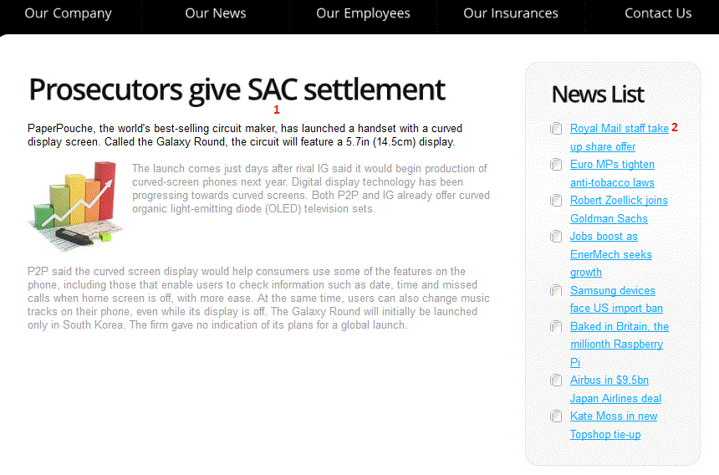

|  |  |  |  |  |  |  |
| --- | --- | --- | --- | --- | --- | --- |
| **No.** | **Name** | **Type** | **Validation** | **Event** | **Description** | **Status** |
| 1 | lblNewscontent | Label |  |  | All content of news |  |
| 2 | NewsList | HyperLink |  | Click | Show content of news |  |

**3.2.15 ViewClaims page**

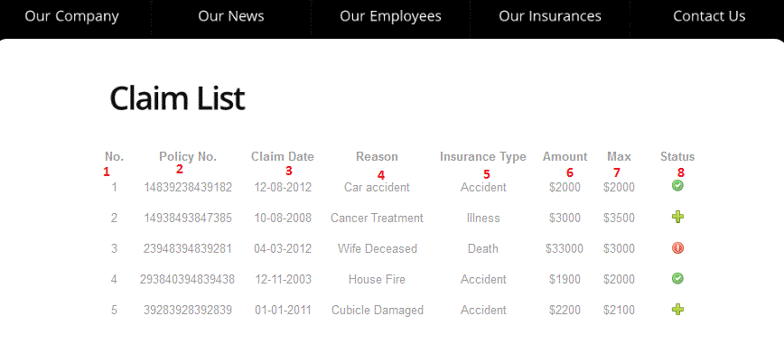

|  |  |  |  |  |  |  |
| --- | --- | --- | --- | --- | --- | --- |
| **No.** | **Name** | **Type** | **Validation** | **Event** | **Description** | **Status** |
| 1 | lblNo | Label |  |  | Ordinal number |  |
| 2 | lblPolicyNo | Label |  |  | Ordinal number of Policy |  |
| 3 | lblClaimDate | Label |  |  | Date of Claim |  |
| 4 | lblReason | Label |  |  | Reason of Claim |  |
| 5 | lblInsuranceType | Label |  |  | Type of Insurance |  |
| 6 | lblAmount | Label |  |  | Amount Claim |  |
| 7 | lblMax | Label |  |  | Maximum amount of Claim |  |
| 8 | imgStatus | Image |  |  | Image of Status |  |

**3.2.16 RetrievePassword page**

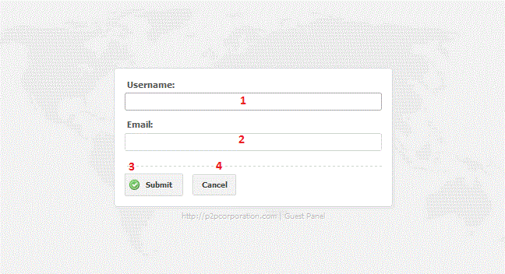

|  |  |  |  |  |  |  |
| --- | --- | --- | --- | --- | --- | --- |
| **No.** | **Name** | **Type** | **Validation** | **Event** | **Description** | **Status** |
| 1 | txtUsername | Text field | Not null |  | Input Username |  |
| 2 | txtPassword | Text field | Not null |  | Input Password |  |
| 3 | btnSubmit | Button |  | Click | Submit information and show a message |  |
| 4 | btnCancel | Button |  | Click | Redirect to Login page |  |

|  |  |  |
| --- | --- | --- |
|  | **Prepared by (Student)** | **Approved by (Faculty)** |
| **Signature** | Team leader  **Dang Tran Ngoc Phuong** | **Kieu Trong Khanh** |
| **Date** |  |  |

TASK SHEET

TASK SHEET

|  |  |  |  |  |  |  |  |  |
| --- | --- | --- | --- | --- | --- | --- | --- | --- |
| **Project Ref. No 1** | | **Project Title** | **Activity Plan Prepared By** | **Date of Preparation of Activity Plan** | | | | |
| **Sr. No** | **Task** | **Start Date** | **End Date** | **Actual Days** | **Member’s name** | **Status** |
| **CRS document** | | | | | | | | |
| 1 | Introduction | Web Based Claim Processing | Dang Tran Ngoc Phuong | 09/23/2013 | 10/23/2013 | 3 | All of Team | FINISH |
| 2 | Existing Scenario | Web Based Claim Processing | Dang Tran Ngoc Phuong | 09/23/2013 | 10/23/2013 | 3 | All of Team | FINISH |
| 3 | Customer Requirement Specification | Web Based Claim Processing | Dang Tran Ngoc Phuong | 09/23/2013 | 10/23/2013 | 3 | All of Team | FINISH |
| 4 | Functional Requirement Specification | Web Based Claim Processing | Dang Tran Ngoc Phuong | 09/23/2013 | 10/23/2013 | 3 | All of Team | FINISH |
| 5 | System Requirements | Web Based Claim Processing | Dang Tran Ngoc Phuong | 09/23/2013 | 10/23/2013 | 3 | All of Team | FINISH |
| 6 | Development Software | Web Based Claim Processing | Dang Tran Ngoc Phuong | 09/23/2013 | 10/23/2013 | 3 | All of Team | FINISH |
| **Use Case and Sequence Diagrams** | | | | | | | | |
| 7 | Register as Buyer | Web Based Claim Processing | Dang Tran Ngoc Phuong | 09/23/2013 | 10/23/2013 | 4 | Pham Viet Hien | FINISH |
| 8 | Register as Seller | Web Based Claim Processing | Dang Tran Ngoc Phuong | 09/23/2013 | 10/23/2013 | 4 | Pham Viet Hien | FINISH |
| 9 | Submit Enquiry | Web Based Claim Processing | Dang Tran Ngoc Phuong | 09/23/2013 | 10/23/2013 | 4 | Le Viet Truc | FINISH |
| 10 | Login | Web Based Claim Processing | Dang Tran Ngoc Phuong | 09/23/2013 | 10/23/2013 | 4 | Pham Viet Hien | FINISH |
| 11 | Logout | Web Based Claim Processing | Dang Tran Ngoc Phuong | 09/23/2013 | 10/23/2013 | 4 | Pham Viet Hien | FINISH |
| 12 | Update Profile | Web Based Claim Processing | Dang Tran Ngoc Phuong | 09/23/2013 | 10/23/2013 | 4 | Pham Viet Hien | FINISH |
| 13 | Buy GoldBuyer Package | Web Based Claim Processing | Dang Tran Ngoc Phuong | 09/23/2013 | 10/23/2013 | 4 | Pham Viet Hien | FINISH |
| 14 | Buyer Search: House for sale, House for rent, room for rent | Web Based Claim Processing | Dang Tran Ngoc Phuong | 09/23/2013 | 10/23/2013 | 4 | Pham Viet Hien | FINISH |
| 15 | View List of Search Queries | Web Based Claim Processing | Dang Tran Ngoc Phuong | 09/23/2013 | 10/23/2013 | 4 | Pham Viet Hien | FINISH |
| 16 | View Search Query | Web Based Claim Processing | Dang Tran Ngoc Phuong | 09/23/2013 | 10/23/2013 | 4 | Pham Viet Hien | FINISH |
| 17 | View List of Shortcuts | Web Based Claim Processing | Dang Tran Ngoc Phuong | 09/23/2013 | 10/23/2013 | 4 | Nguyen Hai Dang | FINISH |
| 18 | Save Shortcut | Web Based Claim Processing | Dang Tran Ngoc Phuong | 09/23/2013 | 10/23/2013 | 4 | Nguyen Hai Dang | FINISH |
| 19 | Delete Shorcut | Web Based Claim Processing | Dang Tran Ngoc Phuong | 09/23/2013 | 10/23/2013 | 4 | Nguyen Hai Dang | FINISH |
| 20 | GoldBuyer Search: House for sale, House for rent, room for rent | Web Based Claim Processing | Dang Tran Ngoc Phuong | 09/23/2013 | 10/23/2013 | 4 | Pham Viet Hien | FINISH |
| 21 | Send Message to Seller | Web Based Claim Processing | Dang Tran Ngoc Phuong | 09/23/2013 | 10/23/2013 | 4 | Nguyen Hai Dang | FINISH |
| 22 | View Property Detail as GoldBuyer | Web Based Claim Processing | Dang Tran Ngoc Phuong | 09/23/2013 | 10/23/2013 | 4 | Nguyen Hai Dang | FINISH |
| 22 | View List of Propertis for Sale (buyProperites.jsp) | Web Based Claim Processing | Dang Tran Ngoc Phuong | 09/23/2013 | 10/23/2013 | 4 | Nguyen Hai Dang | FINISH |
| 23 | View List of Propertis for Rent (rentProperites.jsp) | Web Based Claim Processing | Dang Tran Ngoc Phuong | 09/23/2013 | 10/23/2013 | 4 | Nguyen Hai Dang | FINISH |
| 24 | View List of Rooms for Rent (rentRooms.jsp) | Web Based Claim Processing | Dang Tran Ngoc Phuong | 09/23/2013 | 10/23/2013 | 4 | Nguyen Hai Dang | FINISH |
| 25 | Post Property: House for sale, House for rent, room for rent | Web Based Claim Processing | Dang Tran Ngoc Phuong | 09/23/2013 | 10/23/2013 | 4 | Tran Thanh Duy | FINISH |
| 26 | Modify Property: House for sale, House for rent, room for rent | Web Based Claim Processing | Dang Tran Ngoc Phuong | 09/23/2013 | 10/23/2013 | 4 | Tran Thanh Duy | FINISH |
| 27 | Delete Property | Web Based Claim Processing | Dang Tran Ngoc Phuong | 09/23/2013 | 10/23/2013 | 4 | Tran Thanh Duy | FINISH |
| 28 | Activate Property | Web Based Claim Processing | Dang Tran Ngoc Phuong | 09/23/2013 | 10/23/2013 | 4 | Tran Thanh Duy | FINISH |
| 29 | Deactivate Property | Web Based Claim Processing | Dang Tran Ngoc Phuong | 09/23/2013 | 10/23/2013 | 4 | Tran Thanh Duy | FINISH |
| 30 | View List of Properties (owner only) | Web Based Claim Processing | Dang Tran Ngoc Phuong | 09/23/2013 | 10/23/2013 | 4 | Tran Thanh Duy | FINISH |
| 31 | View Property Detail (owner only) | Web Based Claim Processing | Dang Tran Ngoc Phuong | 09/23/2013 | 10/23/2013 | 4 | Tran Thanh Duy | FINISH |
| 32 | Change Password | Web Based Claim Processing | Dang Tran Ngoc Phuong | 09/23/2013 | 10/23/2013 | 4 | Le Viet Truc | FINISH |
| 33 | View List of Administrators | Web Based Claim Processing | Dang Tran Ngoc Phuong | 09/23/2013 | 10/23/2013 | 4 | Le Viet Truc | FINISH |
| 34 | Add Administrator | Web Based Claim Processing | Dang Tran Ngoc Phuong | 09/23/2013 | 10/23/2013 | 4 | Le Viet Truc | FINISH |
| 35 | Delete Administrator | Web Based Claim Processing | Dang Tran Ngoc Phuong | 09/23/2013 | 10/23/2013 | 4 | Le Viet Truc | FINISH |
| 36 | Update Advertisement Price | Web Based Claim Processing | Dang Tran Ngoc Phuong | 09/23/2013 | 10/23/2013 | 4 | Le Viet Truc | FINISH |
| 37 | View List of Banks | Web Based Claim Processing | Dang Tran Ngoc Phuong | 09/23/2013 | 10/23/2013 | 4 | Nguyen Hai Dang | FINISH |
| 38 | Add Bank | Web Based Claim Processing | Dang Tran Ngoc Phuong | 09/23/2013 | 10/23/2013 | 4 | Nguyen Hai Dang | FINISH |
| 39 | Modify Bank | Web Based Claim Processing | Dang Tran Ngoc Phuong | 09/23/2013 | 10/23/2013 | 4 | Nguyen Hai Dang | FINISH |
| 40 | Delete Bank | Web Based Claim Processing | Dang Tran Ngoc Phuong | 09/23/2013 | 10/23/2013 | 4 | Nguyen Hai Dang | FINISH |
| 41 | View List of Properties (for Administrators) | Web Based Claim Processing | Dang Tran Ngoc Phuong | 09/23/2013 | 10/23/2013 | 4 | Le Viet Truc | FINISH |
| 42 | View List of Customers | Web Based Claim Processing | Dang Tran Ngoc Phuong | 09/23/2013 | 10/23/2013 | 4 | Le Viet Truc | FINISH |
| 43 | Ban Customer | Web Based Claim Processing | Dang Tran Ngoc Phuong | 09/23/2013 | 10/23/2013 | 4 | Le Viet Truc | FINISH |
| 44 | View Customer Detail | Web Based Claim Processing | Dang Tran Ngoc Phuong | 09/23/2013 | 10/23/2013 | 4 | Le Viet Truc | FINISH |
| 45 | View List of Directories | Web Based Claim Processing | Dang Tran Ngoc Phuong | 09/23/2013 | 10/23/2013 | 4 | Le Viet Truc | FINISH |
| 46 | Add Directory | Web Based Claim Processing | Dang Tran Ngoc Phuong | 09/23/2013 | 10/23/2013 | 4 | Le Viet Truc | FINISH |
| 47 | Modify Directory | Web Based Claim Processing | Dang Tran Ngoc Phuong | 09/23/2013 | 10/23/2013 | 4 | Le Viet Truc | FINISH |
| 48 | Delete Directory | Web Based Claim Processing | Dang Tran Ngoc Phuong | 09/23/2013 | 10/23/2013 | 4 | Le Viet Truc | FINISH |
| 49 | View List of Directory Categories | Web Based Claim Processing | Dang Tran Ngoc Phuong | 09/23/2013 | 10/23/2013 | 4 | Le Viet Truc | FINISH |
| 50 | Add Directory Category | Web Based Claim Processing | Dang Tran Ngoc Phuong | 09/23/2013 | 10/23/2013 | 4 | Le Viet Truc | FINISH |
| 51 | Modify Directory Category | Web Based Claim Processing | Dang Tran Ngoc Phuong | 09/23/2013 | 10/23/2013 | 4 | Le Viet Truc | FINISH |
| 52 | Delete Directory Category | Web Based Claim Processing | Dang Tran Ngoc Phuong | 09/23/2013 | 10/23/2013 | 4 | Le Viet Truc | FINISH |
| 53 | View List of FAQs | Web Based Claim Processing | Dang Tran Ngoc Phuong | 09/23/2013 | 10/23/2013 | 4 | Nguyen Hai Dang | FINISH |
| 54 | Add Question | Web Based Claim Processing | Dang Tran Ngoc Phuong | 09/23/2013 | 10/23/2013 | 4 | Nguyen Hai Dang | FINISH |
| 55 | Modify Question | Web Based Claim Processing | Dang Tran Ngoc Phuong | 09/23/2013 | 10/23/2013 | 4 | Nguyen Hai Dang | FINISH |
| 56 | Delete Question | Web Based Claim Processing | Dang Tran Ngoc Phuong | 09/23/2013 | 10/23/2013 | 4 | Nguyen Hai Dang | FINISH |
| **ERD** | | | | | | | | |
| 57 | Conceptual | Web Based Claim Processing | Dang Tran Ngoc Phuong | 09/23/2013 | 10/23/2013 | 4 | All of Team | FINISH |
| 58 | Logical | Web Based Claim Processing | Dang Tran Ngoc Phuong | 09/23/2013 | 10/23/2013 | 4 | All of Team | FINISH |
| 59 | Table | Web Based Claim Processing | Dang Tran Ngoc Phuong | 09/23/2013 | 10/23/2013 | 4 | All of Team | FINISH |
| 60 | Database Relationship | Web Based Claim Processing | Dang Tran Ngoc Phuong | 09/23/2013 | 10/23/2013 | 4 | All of Team | FINISH |
| 61 | Table Definition | Web Based Claim Processing | Dang Tran Ngoc Phuong | 09/23/2013 | 10/23/2013 | 4 | All of Team | FINISH |
| **GUI** | | | | | | | | |
| 62 | home | Web Based Claim Processing | Dang Tran Ngoc Phuong | 09/23/2013 | 10/23/2013 | 4 | All of Team | FINISH |
| 63 | Display advertisement on Home page | Web Based Claim Processing | Dang Tran Ngoc Phuong | 09/23/2013 | 10/23/2013 | 4 | Tran Thanh Duy | FINISH |
| 64 | login | Web Based Claim Processing | Dang Tran Ngoc Phuong | 09/23/2013 | 10/23/2013 | 4 | Pham Viet Hien | FINISH |
| 65 | registerPolicy | Web Based Claim Processing | Dang Tran Ngoc Phuong | 09/23/2013 | 10/23/2013 | 4 | Pham Viet Hien | FINISH |
| 66 | sendEnquiry | Web Based Claim Processing | Dang Tran Ngoc Phuong | 09/23/2013 | 10/23/2013 | 4 | Le Viet Truc | FINISH |
| 67 | updateProfile | Web Based Claim Processing | Dang Tran Ngoc Phuong | 09/23/2013 | 10/23/2013 | 4 | Pham Viet Hien | FINISH |
| 68 | buyGoldBuyerPackage | Web Based Claim Processing | Dang Tran Ngoc Phuong | 09/23/2013 | 10/23/2013 | 4 | Pham Viet Hien | FINISH |
| 69 | listOfSearchQueries | Web Based Claim Processing | Dang Tran Ngoc Phuong | 09/23/2013 | 10/23/2013 | 4 | Pham Viet Hien | FINISH |
| 70 | listOfShortcuts | Web Based Claim Processing | Dang Tran Ngoc Phuong | 09/23/2013 | 10/23/2013 | 4 | Nguyen Hai Dang | FINISH |
| 71 | listOfProperties | Web Based Claim Processing | Dang Tran Ngoc Phuong | 09/23/2013 | 10/23/2013 | 4 | Tran Thanh Duy | FINISH |
| 72 | activateProperty | Web Based Claim Processing | Dang Tran Ngoc Phuong | 09/23/2013 | 10/23/2013 | 4 | Tran Thanh Duy | FINISH |
| 73 | postProperty | Web Based Claim Processing | Dang Tran Ngoc Phuong | 09/23/2013 | 10/23/2013 | 4 | Tran Thanh Duy | FINISH |
| 74 | positionPanels | Web Based Claim Processing | Dang Tran Ngoc Phuong | 09/23/2013 | 10/23/2013 | 4 | Tran Thanh Duy | FINISH |
| 75 | modifyProperty | Web Based Claim Processing | Dang Tran Ngoc Phuong | 09/23/2013 | 10/23/2013 | 4 | Tran Thanh Duy | FINISH |
| 76 | propertyDetail | Web Based Claim Processing | Dang Tran Ngoc Phuong | 09/23/2013 | 10/23/2013 | 4 | Nguyen Hai Dang  & Tran Thanh Duy | FINISH |
| 77 | Loan information | Web Based Claim Processing | Dang Tran Ngoc Phuong | 09/23/2013 | 10/23/2013 | 4 | Nguyen Hai Dang | FINISH |
| 78 | view Google Map | Web Based Claim Processing | Dang Tran Ngoc Phuong | 09/23/2013 | 10/23/2013 | 4 | Nguyen Hai Dang | FINISH |
| 79 | Choose Google Map for Property | Web Based Claim Processing | Dang Tran Ngoc Phuong | 09/23/2013 | 10/23/2013 | 4 | Nguyen Hai Dang | FINISH |
| 80 | Choose position for property | Web Based Claim Processing | Dang Tran Ngoc Phuong | 09/23/2013 | 10/23/2013 | 4 | Tran Thanh Duy | FINISH |
| 81 | sendMessageToSeller | Web Based Claim Processing | Dang Tran Ngoc Phuong | 09/23/2013 | 10/23/2013 | 4 | Nguyen Hai Dang | FINISH |
| 82 | search | Web Based Claim Processing | Dang Tran Ngoc Phuong | 09/23/2013 | 10/23/2013 | 4 | Pham Viet Hien | FINISH |
| 83 | faq | Web Based Claim Processing | Dang Tran Ngoc Phuong | 09/23/2013 | 10/23/2013 | 4 | Nguyen Hai Dang | FINISH |
| 84 | adminHome | Web Based Claim Processing | Dang Tran Ngoc Phuong | 09/23/2013 | 10/23/2013 | 4 | Le Viet Truc | FINISH |
| 85 | loginAdmin | Web Based Claim Processing | Dang Tran Ngoc Phuong | 09/23/2013 | 10/23/2013 | 4 | Le Viet Truc | FINISH |
| 86 | listOfCustomers | Web Based Claim Processing | Dang Tran Ngoc Phuong | 09/23/2013 | 10/23/2013 | 4 | Le Viet Truc | FINISH |
| 87 | customerDetail | Web Based Claim Processing | Dang Tran Ngoc Phuong | 09/23/2013 | 10/23/2013 | 4 | Le Viet Truc | FINISH |
| 88 | updateAdvsPrice | Web Based Claim Processing | Dang Tran Ngoc Phuong | 09/23/2013 | 10/23/2013 | 4 | Le Viet Truc | FINISH |
| 89 | listOfDirectories | Web Based Claim Processing | Dang Tran Ngoc Phuong | 09/23/2013 | 10/23/2013 | 4 | Le Viet Truc | FINISH |
| 90 | addDirectory | Web Based Claim Processing | Dang Tran Ngoc Phuong | 09/23/2013 | 10/23/2013 | 4 | Le Viet Truc | FINISH |
| 91 | modifyDirectory | Web Based Claim Processing | Dang Tran Ngoc Phuong | 09/23/2013 | 10/23/2013 | 4 | Le Viet Truc | FINISH |
| 92 | listOfDirectoryCategories | Web Based Claim Processing | Dang Tran Ngoc Phuong | 09/23/2013 | 10/23/2013 | 4 | Le Viet Truc | FINISH |
| 93 | addDirectoryCategory | Web Based Claim Processing | Dang Tran Ngoc Phuong | 09/23/2013 | 10/23/2013 | 4 | Le Viet Truc | FINISH |
| 94 | modifyDirectoryCategory | Web Based Claim Processing | Dang Tran Ngoc Phuong | 09/23/2013 | 10/23/2013 | 4 | Le Viet Truc | FINISH |
| 95 | listOfBanks | Web Based Claim Processing | Dang Tran Ngoc Phuong | 09/23/2013 | 10/23/2013 | 4 | Nguyen Hai Dang | FINISH |
| 96 | addBank | Web Based Claim Processing | Dang Tran Ngoc Phuong | 09/23/2013 | 10/23/2013 | 4 | Nguyen Hai Dang | FINISH |
| 97 | modifyBank | Web Based Claim Processing | Dang Tran Ngoc Phuong | 09/23/2013 | 10/23/2013 | 4 | Nguyen Hai Dang | FINISH |
| 98 | listOfFAQs | Web Based Claim Processing | Dang Tran Ngoc Phuong | 09/23/2013 | 10/23/2013 | 4 | Nguyen Hai Dang | FINISH |
| 99 | addFAQ | Web Based Claim Processing | Dang Tran Ngoc Phuong | 09/23/2013 | 10/23/2013 | 4 | Nguyen Hai Dang | FINISH |
| 100 | modifyFAQ | Web Based Claim Processing | Dang Tran Ngoc Phuong | 09/23/2013 | 10/23/2013 | 4 | Nguyen Hai Dang | FINISH |
| 101 | listOfAdministrators | Web Based Claim Processing | Dang Tran Ngoc Phuong | 09/23/2013 | 10/23/2013 | 4 | Le Viet Truc | FINISH |
| 102 | addAdministrator | Web Based Claim Processing | Dang Tran Ngoc Phuong | 09/23/2013 | 10/23/2013 | 4 | Le Viet Truc | FINISH |
| 104 | report | Web Based Claim Processing | Dang Tran Ngoc Phuong | 09/23/2013 | 10/23/2013 | 4 | All of Team | FINISH |
| 105 | changePassowrd | Web Based Claim Processing | Dang Tran Ngoc Phuong | 09/23/2013 | 10/23/2013 | 4 | Le Viet Truc | FINISH |
| **Report** | | | | | | | | |
| 106 | reportCustomers | Web Based Claim Processing | Dang Tran Ngoc Phuong | 09/23/2013 | 10/23/2013 | 4 | Pham Viet Hien | FINISH |
| 107 | reportProperties | Web Based Claim Processing | Dang Tran Ngoc Phuong | 09/23/2013 | 10/23/2013 | 4 | Tran Thanh Duy | FINISH |
| 108 | reportBanks | Web Based Claim Processing | Dang Tran Ngoc Phuong | 09/23/2013 | 10/23/2013 | 4 | Nguyen Hai Dang | FINISH |
| 109 | reportDirectories | Web Based Claim Processing | Dang Tran Ngoc Phuong | 09/23/2013 | 10/23/2013 | 4 | Le Viet Truc | FINISH |
| **Permission Security** | | | | | | | | |
| 110 | Home page | Web Based Claim Processing | Dang Tran Ngoc Phuong | 09/23/2013 | 10/23/2013 | 4 | Le Viet Truc | FINISH |
| 111 | Admin page | Web Based Claim Processing | Dang Tran Ngoc Phuong | 09/23/2013 | 10/23/2013 | 4 | Le Viet Truc | FINISH |
| **Task sheet** | | | | | | | | |
| 112 | Task sheet | Web Based Claim Processing | Dang Tran Ngoc Phuong | 09/23/2013 | 10/23/2013 | 1 | Le Viet Truc | FINISH |

|  |  |  |
| --- | --- | --- |
|  | **Prepared by (Student)** | **Approved by (Faculty)** |
| **Signature** | Team leader  **Le Viet Truc** | **Kieu Trong Khanh** |
| **Date** |  |  |